*Concreep12 conference, June 5 –7, 20244*

*Delft University of Technology, Delft, The Netherlands*

**Abstract:**

# Abstract Title of the research paper (Title case, Bold, Times New Roman, 16 pt font)

First Author a*, Second Author a, b and Third Author a

a First affiliation and address

b Second affiliation and address

* Corresponding author: email address of the corresponding author

The extended abstract should range from 2 to 4 pages, and the full paper should not exceed 10 pages. The font of the abstract body should be Times New Roman 11 and the text should be justified. Use single spacing and normal margins. Define all symbols and abbreviation used in the abstract. Please register at the [conference website](http://www.concreep12.org) and submit your abstract.

**Keywords**: 4-6 key words are recommended to be listed here.

1 Introduction

Content of the Introduction section. Summarize current research status of the studied topic, point out the limitations, and distinguish the novelty of this work.

2 Title of the second section

2.1 Title of the subsection

The format of the figure and caption is suggested as in **Fig.1**. Texts referencing to the figures should be bold. The caption should be below the figure, and uses Times New Roman 11 in bold. The figure and caption should both be centered.

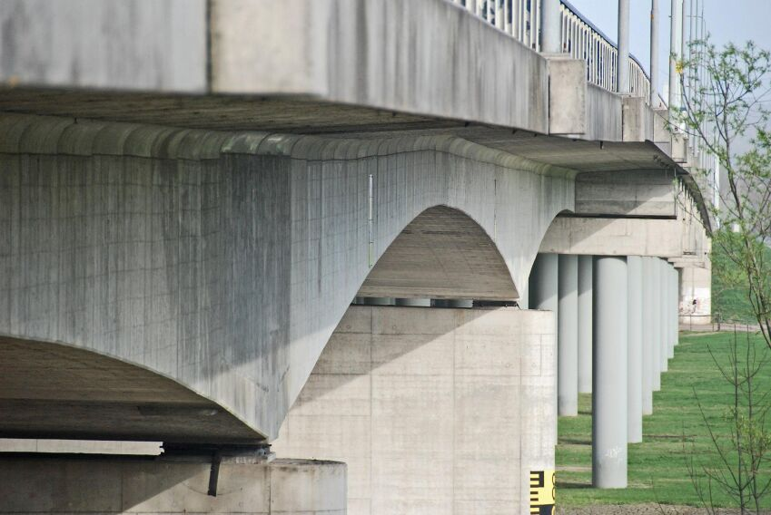

Fig. 1 An example of the figure and caption.

3 Title of the third section

The format of the table and caption is suggested as in **Table.1**. Texts referencing to the tables should be bold. The content of the table uses Times New Roman 11, and the header of each column should be bold. The caption should be on top of the table, and uses Times New Roman 11 in bold.

Table. 1 An example of the table and caption

|  |  |  |  |  |
| --- | --- | --- | --- | --- |
| **Sample name** | **Header 1** | **Header 2** | **Header 3** | **Header 4** |
| Name 1 | content | content | content | content |
| Name 2 | content | content | content | content |
| Name 3 | content | content | content | content |

4 Title of the fourth section

The format of mathematical equation is suggested as the example in **Eq (1)**. The text referencing to the equation should be bold. The font italic Cambria Math 11 is suggested for the equation content. Each variable should be explained below the equation upon its first appearance in this article.

|  |  |
| --- | --- |
|  | (1) |

in which σ is the stress; ε is the imposed strain; R is the relaxation modulus; t0 is the time when the deformation is imposed; t is the current time.

5 Conclusion

Give a brief summary and discussion of this work and list the major findings below:

1. The first finding……
2. The second finding……
3. The third finding……

Reference

List the reference source following the format of the example below. Use Times New Roman 11 for the content of the reference list.

1. Z.P. Bažant, Y. Xi, Continuous Retardation Spectrum for Solidification Theory of Concrete Creep, J Eng Mech. 121 (1995) 281–288.
2. E. Schlangen, E.J. Garboczi, Fracture simulations of concrete using lattice models: Computational aspects, Eng Fract Mech. 57 (1997) 319–332.
3. B. Šavija, J. Pacheco, E. Schlangen, Lattice modeling of chloride diffusion in sound and cracked concrete, Cem Concr Compos. 42 (2013) 30–40.
4. The fourth reference……