From dichotomies to dialogues - connecting discourses for a sustainable urbanism
The 14th conference of the International Forum on Urbanism (IFoU), 25-27 November 2021

The Evolving Scholar Publishing process
The Evolving Scholar (ThES) is a community-driven open-access journal published by TU Delft OPEN. Only accepted abstract will be invited to submit to The Evolving Scholar, a full conference paper or a short conference paper.
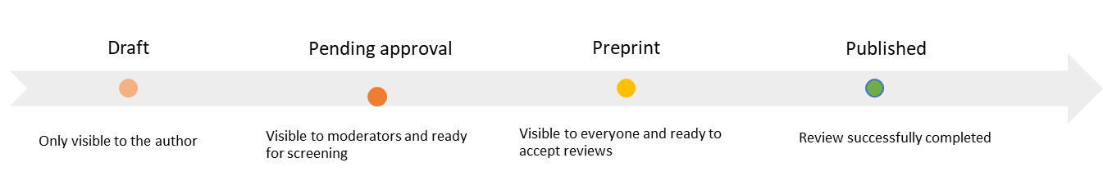
Figure 1. the publication process.
Instructions for authors
- Manuscript preparation
- Make use of our templates to submit your full conference paper or a short conference paper.
- Research Data- Authors are strongly encouraged to register their dataset in a recognised research data repository- please visit this page for more information.
- Open Access Policy
The Evolving Scholar is licensed under one of the following Creative Commons licenses:
  - CC BY 4.0 license. The license means that anyone is free to share (to copy, distribute, and transmit the work), to remix (to adapt the work), however, under the conditions of giving appropriate credit, providing a link to the license, and indicating if changes were made.
  - CC BY-ND 4.0 license. This license lets others reuse the work for any purpose, including commercially; however, it cannot be shared with others in adapted form, and credit must be provided to you.
You will be asked to choose a license during the submission process
- Copyright Policy
  - Authors retain their copyrights.
  - if you are using published images, text or other materials, please be aware of copyright regulations. The TU Delft Copyright helpdesk can provide further information and answer your copyright questions.
  - In case of (alleged or proven) copyright breaches or scientific misconduct (e.g. fabricating data), The Evolving Scholar will follow the guide developed by the Committee on Publication Ethics (COPE)
- Plagiarism
  - All submissions will undergo a similarity check, the results of which will be shared with the scientific community. In case of suspected plagiarism, the authors will have 2 weeks to provide an explanation.
  - Reproducing a part of a published content or images is allowed if the original source and authors are respectively referred to and are given proper credit.

- Submission
- Join the community preferably by using an ORCID ID (personal or via your institutional account).
- Click on The Evolving Scholar community banner.
- Submit your conference paper*.
- Any issues please check this guide or use the feedback button or contact publishing-lib@tudelft.nl
*Please note submissions will be opened on 6th September 2021

- Review process
See figure 1 for the publication process.

Your conference paper will be openly peer-reviewed. It means Authors and Reviewers/Editors are aware of each other’s identity, communicate transparently throughout the entire process.

