5th International RILEM Conference on Numerical Modeling Strategies for Sustainable Concrete Structures, SSCS2025
July 7 –9, 2025, Delft University of Technology, Rotterdam, The Netherlands

Instructions to Prepare Full Paper for the Fifth International RILEM Conference on Numerical Modeling Strategies for Sustainable Concrete Structures SSCS2025

First Author ^{a*}, Second Author ^{a, b} and Third Author ª

ª First affiliation and address

^{b} Second affiliation and address
* Corresponding author: email address of the corresponding author
Abstract:
This document provides information and instructions for preparing a Full Paper to be included in the Proceedings of SSCS 2025Conference.

Keywords: 4-6 key words are recommended to be listed here.

1 Introduction
All participants whose Abstract has been accepted for presentation at the Conference are kindly requested to submit the Full Paper electronically via the SSCS2025 webpage before March 1, 2025. The Full Paper should be written following this format of template for submission. The Full Paper including figures, tables and references must have a minimum length of 6 pages and must not exceed 12 pages and should be written in English. The organizers do not commit themselves to include in the Proceedings any Full Paper received later than the above-mentioned deadline.
The indicated presenter of the contribution has to register and pay the respective registration fee to take advantage of preferential rate before March 1, 2025, and before April 1 for final acceptance.
In the content of Introduction, please summarize current research status of the studied topic, point out the limitations, and distinguish the novelty of this work.

2 Title of the second section

2.1 Title of the subsection
The font of the paper should be Times New Roman 12 and the text should be justified. Use single spacing and normal margins. Define all symbols and abbreviations used. The format of the figure and caption is suggested as in Fig.1. Texts referencing to the figures should be bold. The caption should be below the figure, and uses Times New Roman 12 in bold. The figure and caption should both be centered.
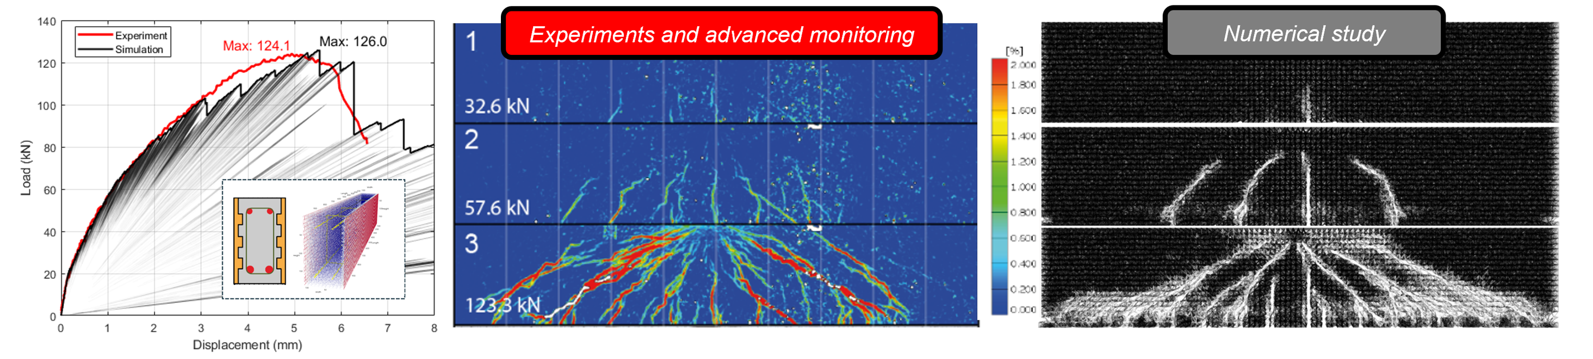
- (b) (c)
Fig. 1 An example of the figure and caption. Fracture behavior of Strain Hardening Cementitious Composite (SHCC) hybrid concrete structure under bending (a) Load displacement curves, (b) damage patterns observed experimentally and (c) numerically.

3 Title of the third section
The format of the table and caption is suggested as in Table.1. Texts referencing to the tables should be bold. The content of the table uses Times New Roman 12, and the header of each column should be bold. The caption should be on top of the table, and uses Times New Roman 12 in bold.

Table. 1 An example of the table and caption
Sample name | Header 1 | Header 2 | Header 3 | Header 4
Name 1 | content | content | content | content
Name 2 | content | content | content | content
Name 3 | content | content | content | content

4 Title of the fourth section
The format of mathematical equation is suggested as the example in Eq (1). The text referencing to the equation should be bold. The font italic Cambria Math 12 is suggested for the equation content. Each variable should be explained below the equation upon its first appearance in this article.
$$σ\left(t\right)=\int_{0}^{t}{R(t_{0},t)\dot{ε}(t_{0})dt_{0}}$$ | (1)
in which σ is the stress; ε is the imposed strain; R is the relaxation modulus; t₀ is the time when the deformation is imposed; t is the current time.

5 Conclusion
Give a brief summary and discussion of this work and list the major findings below:
- The first finding……
- The second finding……
- The third finding……

Reference
List the reference source following the format of the example below. Use Times New Roman 11 for the content of the reference list.
- Z.P. Bažant, Y. Xi, Continuous Retardation Spectrum for Solidification Theory of Concrete Creep, J Eng Mech. 121 (1995) 281–288.
- M. Lukovic, E. Schlangen, G. Ye, B. Savija, Impact of surface roughness on the debonding mechanism in concrete repairs. Proceedings of FraMCoS-8, Toledo, Spain (2013).
- V. Slowik, M. Lukovic, C. Wagner, GPAG van Zijl. Behaviour of bonded SHCC overlay systems, A framework for Durability Design with Strain Hardening Cement-Based Composites (SHCC). STAR of RILEM-TC 24—FDS, Springer (2017).
- ENERPAC. Lateral Bridge Slide Jacking System—Accelerated Bridge Construction. Available online: https://www.youtube.com/watch?v=YzYCSw5mACQ (accessed on 17 January 2025).
- The fifth reference……

