Title of Two-Page-Abstract

Osborne Reynolds^{1,*} and Ernst Mach²
1: Dept. of Mathematics, University of Cambridge, United Kingdom
2: Dept. of Physics, University of Vienna, Austria
* Correspondent author: reynolds@cambridge.org

Keywords: PIV processing, Micro PIV, Microfluidics, Heat transfer

ABSTRACT This is the template to prepare the abstract for the 20th International Symposium on Flow Visualization, Delft, the Netherlands 10 – 13 July 2023. The abstract will be included in the book of abstracts, which will be offered to all the participants. Please follow the guidelines below when preparing your abstract.

GUIDELINES
The abstract may include a clear but brief description of the purpose, methods, results and main conclusions of your study. Read carefully the following 20 guidelines before you write the abstract.

(1) Use an A4 size format (297 mm x 210 mm in height and width).
(2) The margins are Top: 20 mm, Bottom: 20 mm, Left: 15 mm and Right: 15 mm.
(3) In the Header, type “20th International Symposium on Flow Visualization, Delft, the Netherlands ・10 – 13 JULY 2023” with 9 pt. Arial or a similar font.
(4) Use 14 pt. Bold Arial or a similar font for the title.
(5) The title should be flush-centered.
(6) Put one single-line space between the title and the names of authors.
(7) The names should be written with 12 pt. Arial or a similar font.
(8) Do not abbreviate the first and last names. Only the middle names can be written with initials.
(9) Attach a superscript natural number (¹, ², ³, …) at the end of each author to refer the affiliation.
(10) Use 10 pt. Arial or a similar font for the affiliations.
(11) The affiliations should be flush-centered.
(12) Write a natural number and colon (e.g., 1: ) before each affiliation.
(13) The affiliation should contain (i) the name of university, company, organization or institute, (ii) country and (iii) e-mail address for the corresponding author.
(14) Put one single-line space between the affiliation and keywords.
(15) Write “Keywords:” with 10 pt. Bold Arial or a similar font.
(16) Write 4 to 6 keywords with 10 pt. Arial or a similar font. The line of Keywords should be flush-centered.
(17) Set one single-line space between the keywords and the body of abstract.
(18) The body should be written with 10 pt. Times New Roman or a similar font with single line space in a single-column format. Greek symbols are also acceptable to denote several quantities. Figures, equations, tables, photos, images or references can be included if necessary. You can also split the body into sections.
(19) In Equations, use 10 pt. Times New Roman and Symbol or similar fonts.
(20) Be sure not to use two-byte fonts which are typical to Japanese, Chinese and Korean language kits. Two- byte fonts are often unintentionally typed in spaces between words, figures, tables and symbols.

SUBMISSION
Upload the abstract by 1 April, 2023 to the website: https://www.isfv20.org/ . You will have the opportunity to upload the abstract when you register on the website. You can also change your registration details and the abstract before the deadline.

FIGURE EXAMPLE
The figures should be numbered in a caption. Figures that contain labels and number ticks should have font size comparable to that of the text size (10pt). The caption text should be flush centered.

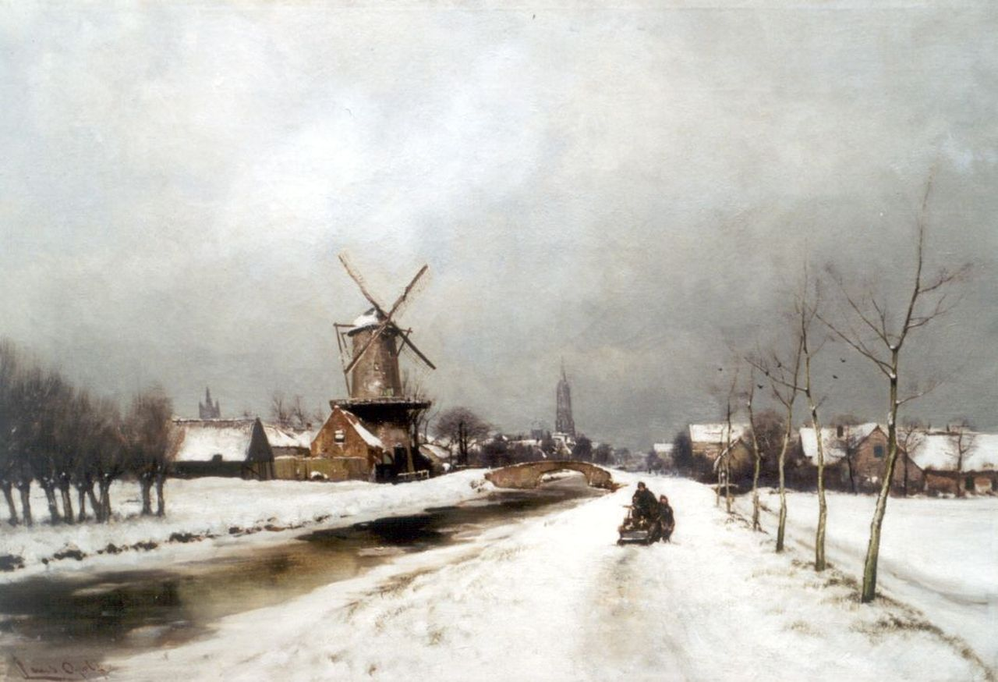
Figure 1. A windmill in a winter landscape near Delft.

EQUATION EXAMPLE
Equations should be typed with font size 10 and should be right-numbered, such that they appear similar to the one below:
 | $$f\left(x\right)=a_{0}+\sum_{n=1}^{∞}{\left(a_{n}\cos{\frac{nπx}{L}}+b_{n}\sin{\frac{nπx}{L}}\right)}.$$ | (1)

REFERENCES
The list of references should be alphabetized by the last names of the first author of each, using the APA formatting. Examples:
- Journal article: Foucaut, J. M., Carlier, J., & Stanislas, M. (2004). PIV optimization for the study of turbulent flow using spectral analysis. Measurement Science and Technology, 15(6), 1046–1058.
- Book: Yarin, A. L., Roisman, I. V., & Tropea, C. (2017). Collision phenomena in liquids and solids. Cambridge University Press.
- Book chapter: Armstrong, R. L. (1988). Laser-induced droplet heating. In Optical Effects Associated with Small Particles (pp. 201-275).

