Dutch Caribbean Heart Days 2026

Executive Board St. Nederlandse Hart Dagen
Prof. R.P.J. Budde, MD, PhD
Prof. H.J. Lamb, MD, PhD
Prof. B.K. Velthuis, MD, PhD

Executive Board NASKHO
F.J. Faulborn, MSc
A.A.E. Martis, PhD
F.M.C. Simon, MSc
Scientific Program Committee Coordinators
Prof. R.P.J. Budde, MD, PhD
F.N. Fernandes, MD, PhD
I. Gerstenbluth, MD
D.F. Holguin, MD
Prof. H.J. Lamb, MD, PhD
J.C.J.. van Leeuwen, MD
C. de Sousa de Ponte, MD
Prof. B.K. Velthuis, MD, PhD

Organizing Committee NASKHO/DCHD
L. Baerecke
I. Engelhardt
S-Y. Mendes
E.J.K. Noach

​​

Venue:
Ballroom of the Renaissance Wind Creek Hotel
Curaçao

3rd Dutch Caribbean Heart Days
Curaçao
15-17 January 2026

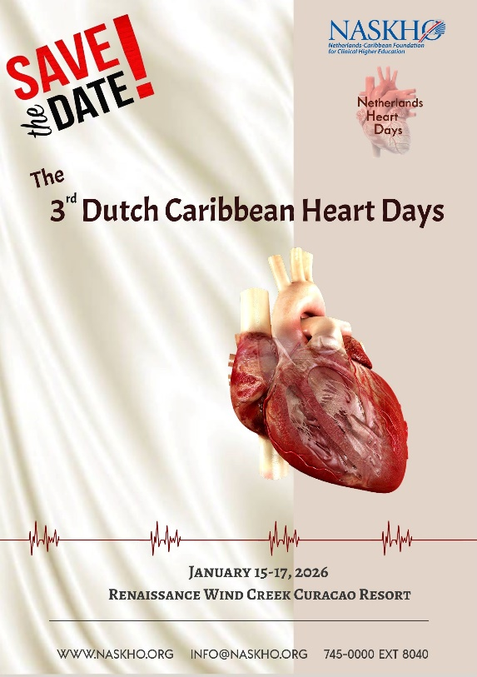

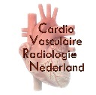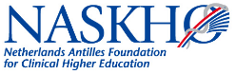

For more information visit www.nnhd. org

Dear Colleagues,

It is with pleasure that we announce the 3rd Dutch Caribbean Heart Days (DCHD) to be held January 15 – 17, 2026 in the Ballroom of the Renaissance Hotel in Willemstad, Curaçao.

With the DCHD, a strong educational platform in (cardiovascular) radiology and cardiology is created for the Caribbean region and South-America, but also for North-America and Europe.

The meeting will feature a spectrum from basic principles towards (advanced) clinical applications and scientific innovations. As part of the main program, an evening session is organized especially for nurses and GP’s. This evening can also as stand- alone session be followed by nurses and GP’s.

Moreover, the program will also be appealing for residents in radiology and cardiology and technicians, pulmonologists and internal medicine MD’s. Besides topical sessions covering the clinical implications of the findings, the technical aspects and imaging protocols, scientific content on cardiac imaging will be addressed. Most sessions will feature examples of actual clinical cases and how novel techniques, methods and interventions can be used to better diagnose and treat patients with a variety of diseases affecting the heart.

The congenial and collaborative atmosphere of the congress offers excellent opportunities for networking and jumpstarting multicenter collaborations and research projects within and over the continents.

Save the date and come join us in Curaçao!

Boards of NASKHO and NHD

PROGRAM Thursday 15 January 2026

08.15 – 08.30 Official Opening and Welcome
Prof. H.J. Lamb, MD, PhD, LUMC, Leiden, NL
08.30 – 09.30
Session 1: CT & CMR Basics
Chair: Prof. H.J. Lamb, MD, PhD, LUMC, Leiden, NL
Guidelines on CT and MRI application
D.F. Holguin, MD, Fundación Cardioinfantil/La Cardio, Bogota, CO
Cardiovascular CT Patient Preparation and Technique
Prof. R.P.J. Budde, MD, PhD, ErasmusMC, Rotterdam, NL
Cardiovascular MRI Technique and Building Blocks
Prof. T. Leiner, MD, PhD, Mayo Clinics, Rochester, US
09.30 – 10.00 Coffee break

10.00 – 11.00
Session 2: Medical Therapy in Coronary Artery Disease
Chair: Prof. B.K. Velthuis, MD, PhD, UMUC, Utrecht, NL
Medical Therapy in Coronary Artery Disease
D.F. Holguin, MD, Fundación Cardioinfantil/La Cardio, Bogota, CO
Anti-Inflammatory Medication in Coronary Artery Disease
A. Mosterd, MD, PhD, Meander MC, Amersfoort, NL
Unmeet needs and New Therapies for Managing LDL Cholesterol
B. Claessen, AmsterdamUMC, Amsterdam, NL
11.00 – 12.00
Session 3: Multi-Energy CT
Chair: J.C.J. van Leeuwen, MD, CMC, Willemstad, CW
Photon Counting CT
Prof. R.P.J. Budde, MD, PhD, ErasmusMC, Rotterdam, NL
Spectral CT: Coronary Artery Disease and Cardiomyopathy
Prof. H.J. Lamb, MD, PhD, LUMC, Leiden, NL
Spectral CT: Extra-Cardiac Vascular Applications
Prof. B.K. Velthuis, MD, PhD UMCU, Utrecht, NL
12.00 – 13.30 Lunch

13.30 – 14.50
Session 4: Ischemic Heart Disease
Chair: Prof. R.P.J. Budde, MD, PhD, ErasmusMC, Rotterdam, NL
Nuclear Imaging
M.E. Hol, MD, UMCU, Utrecht, NL
MRI
Prof. T. Leiner, MD, PhD, Mayo Clinics, Rochester, US
Ultrasound
J.F. Vasquez,MD, Fundación Cardioinfantil/La Cardio, Bogota, CO
Cases
J.C.J. van Leeuwen, MD, CMC, Willemstad, CW

18.30 – 20.30 Session 5: Imaging for Nurses and General Practitioners (GPS)
Chairs: C. de Sousa de Ponte, MD and J.C.J. van Leeuwen, MD, CMC, Willemstad, CW
Heart Failure in the First Line
M. Meraz Torres, MD, AAH, Willemstad, CW
Policlinical Electrocardiography
C. Diaz, CMC, Willemstad, CW
Basic Electrocardiography
J.C.J. van Leeuwen, MD, CMC, Willemstad, CW
Care for the CCU Patient
R. Mathilda, CMC, Willemstad, CW
Loop Recorders
L. Martina, CMC, Willemstad, CW
Panel Discussion
All speakers

PROGRAM Friday 16 January 2026

08.15 – 08.30 Walk in

08.30 – 09.30
Session 6: Basic Principles of Cardiac Ultrasound & Nuclear Medicine
Chair: Prof. H.J. Lamb, MD, PhD, LUMC, Leiden, NL
When to perform Cardiovascular Ultrasound
T. Martha, MD, CMC, Willemstad, CW
How to perform Cardiovascular Ultrasound
J. Molina Monsalve, MD, CMC, Willemstad, CW
Clinical Indications for Nuclear Imaging
M.E. Hol, MD, UMCU, Utrecht, NL
09.30 – 10.00 Coffee break

10.00 – 11.00
Session 7: Sports Medicine
Chair: A. Mosterd, MD, PhD, Meander MC, Amersfoort, NL
Pre-Participation Screening of Athletes - to do or not to do
A. Mosterd, MD, PhD, Meander MC, Amersfoort, NL
CT and MRI Imaging of the Athletes Heart
Prof. B.K. Velthuis, MD, PhD, UMCU, Utrecht, NL
Cardiovascular Challenges of Scuba Diving
J.C.J. van Leeuwen, MD, CMC, Willemstad, CW

11.00 – 12.00
Session 8: Inflammation
Chair: M.E. Hol, MD, UMCU, Utrecht, NL
Cardiac Sarcoidosis and Other Inflammatory Disease
M.E. Hol, MD, UMCU, Utrecht, NL
Role of the CMR in Myocarditis
C.E. Guerrero, MD, Fundación Cardioinfantil/La Cardio, Bogota, CO
Cases
Prof. B.K. Velthuis, MD, PhD, UMCU, Utrecht, NL

12.00 – 13.30 Lunch

13.30 – 14.50
Session 9: Non-Ischemic Heart Disease
Chair: Prof. R.P.J. Budde, MD, PhD, ErasmusMC, Rotterdam, NL
Echo Primers in Congenital Heart Disease – What you must know!
C.E. Guerrero, MD, Fundación Cardioinfantil/La Cardio, Bogota, CO
Hypertrophic Cardiomyopathy and Hypertensive Cardiomyopathy
Prof. B.K. Velthuis, MD, PhD, UMCU, Utrecht, NL
Valvular Heart Disease
Prof. R.P.J. Budde, MD, PhD, ErasmusMC, Rotterdam, NL
Cases
Prof. R.O.B. Gans, MD, PhD, CMC, Willemstad, CW

PROGRAM Saturday 17 January 2026

08.15 – 08.30 Walk in

08.30 – 09.30
Session 10: Artificial Intelligence
Chair: Prof. B.K. Velthuis, MD, PhD, UMUC, Utrecht, NL
Basic Principles of AI
Prof. H.J. Lamb, MD, PhD, LUMC, Leiden, NL
Cardiovascular Imaging Applications of AI
Prof. H.J. Lamb, MD, PhD, LUMC, Leiden, NL
Translating AI across Disciplines. Insights from Neuro-Oncology to Cardiology
J.C.C. van Leeuwen, MSc, ErasmusMC, Rotterdam, NL

09.30 – 10.00 Coffee break

10.00 – 11.00
Session 11: Inflammation, Behavior and Environmental Effects
Chair: Prof. H.J. Lamb, MD, PhD, LUMC, Leiden, NL
The Inflammatory Nature of Obesity
Prof. A.J. Duits, MD, PhD, CMC, Willemstad, CW
Metabolic Programming of Obesity
S. van Heijningen, PhD, Scientific Consulting Curaçao, Willemstad, CW
What does Climate Change have to do with us?
I. Gerstenbluth, MD, Curaçao Biomedical & Health Research Institute, Willemstad, CW

11.00 – 12.00
Session 12: Intervention
Chair: Prof. R.P.J. Budde, MD, PhD, ErasmusMC, Rotterdam, NL
FARAPULSE Ablations
OSAS
T. Blonk, MD, CMC, Willemstad, CW
3D+ to the Point of Care – Upgrading Preprocedural Planning
C.E. Guerrero, MD, Fundación Cardioinfantil/La Cardio, Bogota, CO

12.00 – 13.30 Lunch

13.30 – 14.50
Session 13: Future of Cardiovascular Imaging
Chair: J.C.J. van Leeuwen, MD, CMC, Willemstad, CW
Free-Breathing CMR
Prof. H.J. Lamb, MD, PhD, LUMC, Leiden, NL
Midfield CMR
Prof. H.J. Lamb, MD, PhD, LUMC, Leiden, NL
3D Ultrasound
J.F. Vasquez, MD, Fundación Cardioinfantil/La Cardio, Bogota, CO
Wrap up Cases
F.N. Fernandes, MD, PhD, CMC, Willemstad, CW

14.50 – 15.00
Closure of the meeting
Prof. H.J. Lamb, MD, PhD, LUMC, Leiden, NL

