K Hotels Dunnan (柯達大飯店台北敦南店)
http://dunnan.khotels.com.tw/en/
Approximately 14 minutes walk to National Taiwan University

Just Sleep Taipei Linsen Branch (台大捷絲旅 台北林森館)
https://www.justsleephotels.com/linsen/tw

Near Bus Station
Take a bus from Linsen North Road to Gongguan MRT Station. The whole journey takes about 30 minutes.
Fare = NT$ 15
From: Linsen North Road 1 to MRT Gongguan Station
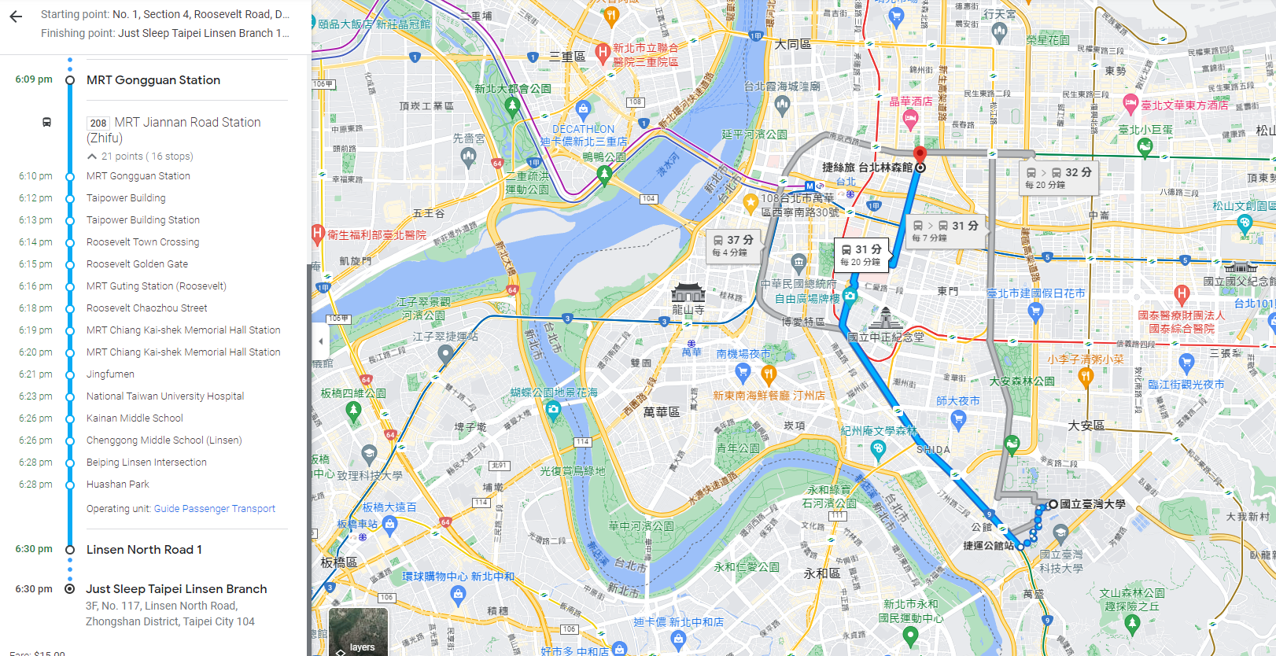

Just Sleep Taipei Ximending (捷絲旅台北西門館)
https://reurl.cc/NqjNom
Near MRT Station
Take a MRT from Ximen MRT Station and get off at Taipei Gongguan Station,
The journey takes about 30 minutes.
Fare = NT$ 20
Metro Taipei Web.: https://english.metro.taipei/
Station (green line) : G07 - G12
