Choose contribution

*FRAMily 2025*

*Safety-II-in-Practice 2025*

**Abstract Title: bolded, 12-point Times New Roman, centered**

**Presenting author name, other co-author’s names: bolded, 11-point Times New Roman, centered**

**University/company/organization affiliation, incl. city, country: bolded, 11-point Times New Roman, centered, 1.5 spaced**

**Keywords: Keyword 1, keyword 2**

**Introduction:** The body of your abstract should be an explicit summary of your presentation that describe the rationale for the research project including relevant background information, methods, results, and a brief discussion/conclusion. Do not include acronyms, bullets, or lists in the abstract. It should be single-spaced in 11-point Times New Roman. Please replace these instructions with the text of your abstract. Page margins are set to be one inch on all sides.

**Methods:** Your abstract should also describe the research methods; this section should include a concise description of the process by which you conducted your research. Think for example about data collection information, method of analysis, etc.

**Results and Discussion:** List the results or outcomes of the work you have done so far. If your project is not yet complete, you may still include preliminary results.

**Conclusion:** Finally, the abstract should close with a statement of the project’s implications and contributions to its field. It should convince readers that the project is interesting, valuable, and worth investigating further. If preferable, the conclusion can be part of the results and discussion without having its own title.

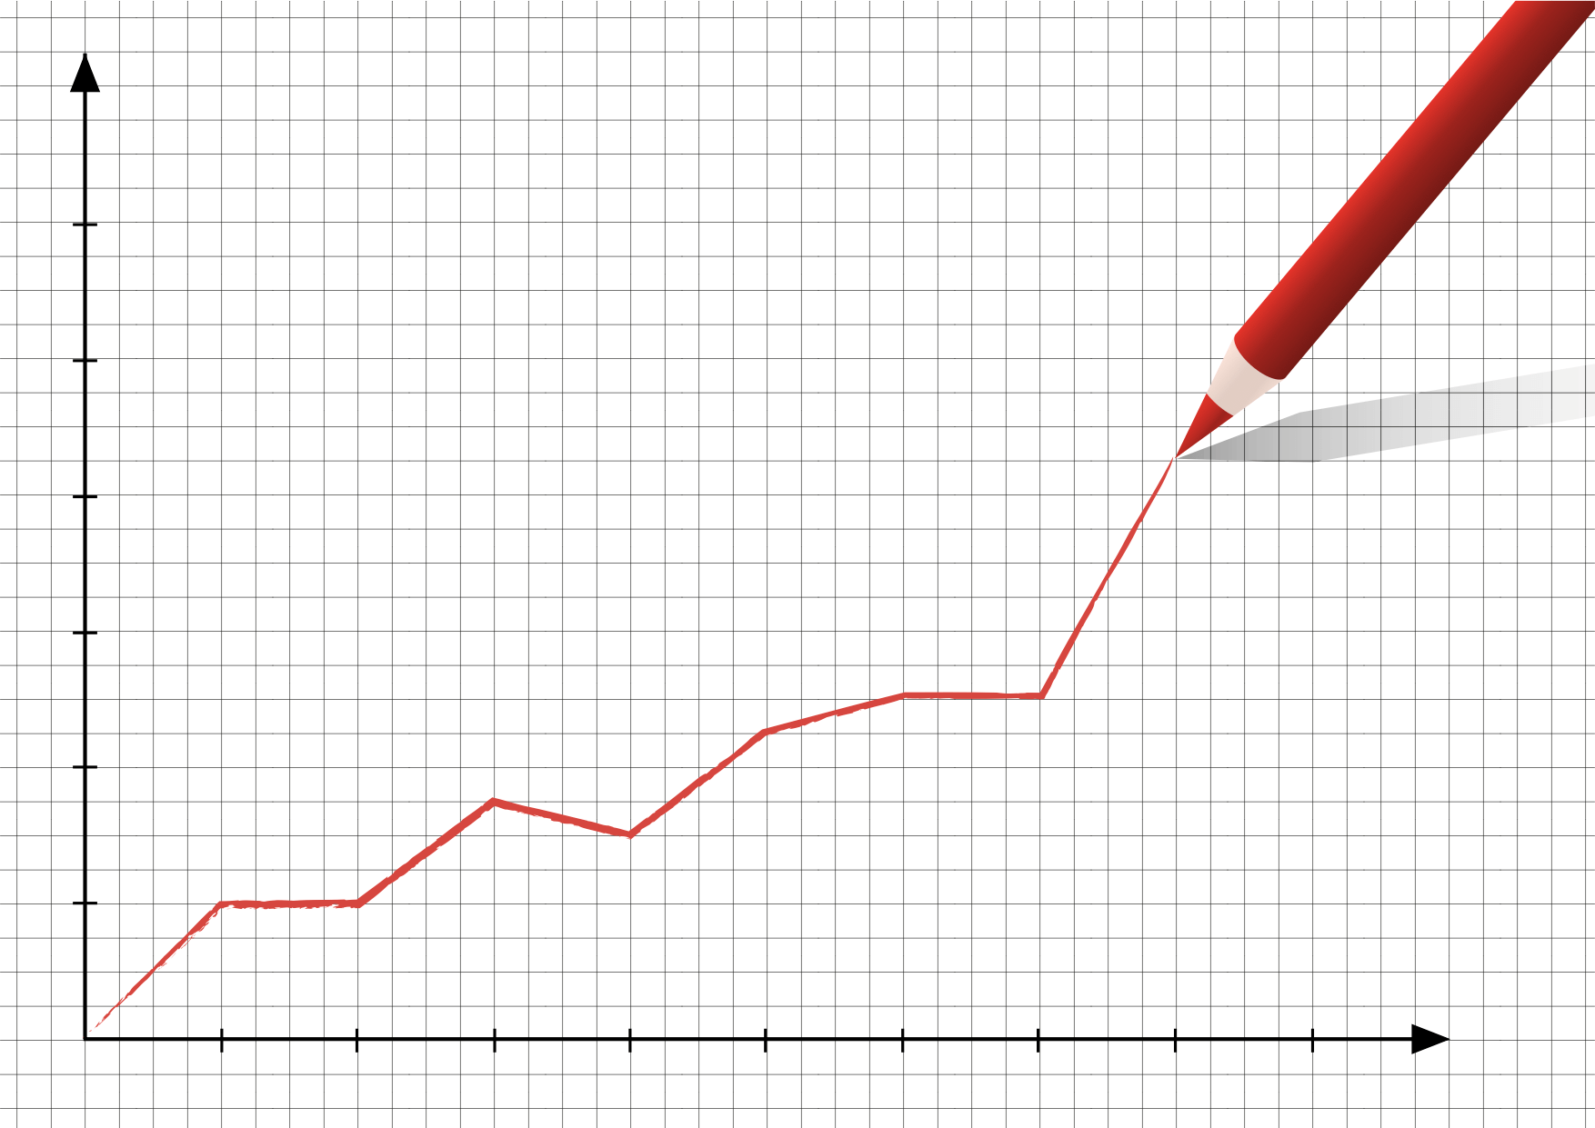

**Insert Figure caption here**

The content of the abstract will be the basis for acceptance of the paper presentation at the research day. The abstracts will be peer reviewed and authors will be informed about acceptance for presentation via email. Not all abstracts, even if accepted, will lead to a presentation, as we want to keep a Be sure to adhere to the word limitation for the abstract. The entire abstract submission should fit between 1 and 2 pages, with a hard limit of 3 pages. We recommend that you download these directions as a MS Word document and use it as the template for your abstract as it contains all necessary formats and styles.

**Figure:** Figures are accepted. If you are including graphs, tables, or photos, they must be imported into this file.

**Acknowledgments**: If your project was supported with internal or external funding, you are encouraged to cite the funding source and/or provide an acknowledgment.

**References:** Use a brief numbered style, e.g., [1], [2]. References should appear in numerical order in the reference list:

[1] Author A. B. and Author C. D. (2021) Med, 90, 1151–1154. [2] Author E. F. et al. (2020) Sci., 32, A74.

**Conference / Workshop suggestions for interaction with the audience if you are selected for presentation:** We will also take into account your suggestion for producing an interactive conference/workshop experience**.**