Hotel recommendation
K Hotels Dunnan (柯達大飯店台北敦南店)
http://dunnan.khotels.com.tw/en/
Approximately 14 minutes walk to National Taiwan University

Just Sleep Taipei Linsen Branch (台大捷絲旅 台北林森館)
https://www.justsleephotels.com/linsen/tw

Near Bus Station
Take a bus from Linsen North Road to Gongguan MRT Station. The whole journey takes about 30 minutes.
Fare = NT$ 15
From: Linsen North Road 1 to MRT Gongguan Station
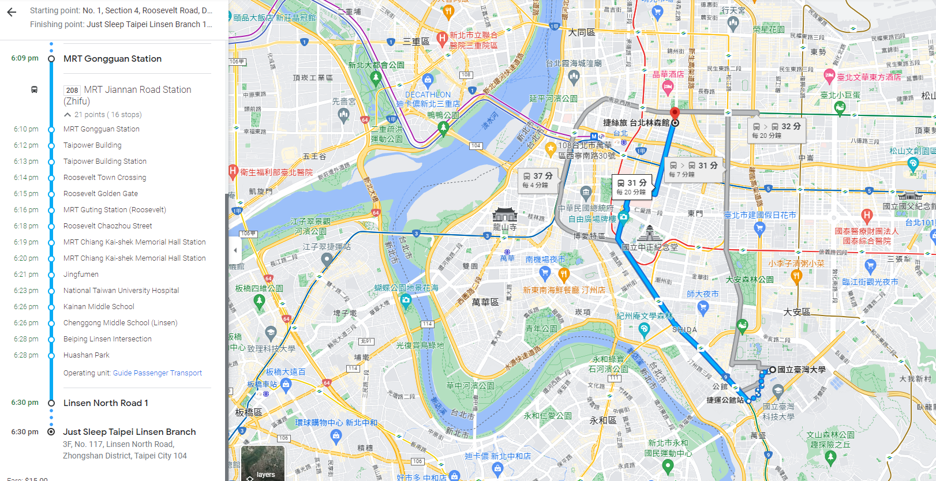

Just Sleep Taipei Ximending (捷絲旅台北西門館)
https://reurl.cc/NqjNom
Near MRT Station
Take a MRT from Ximen MRT Station and get off at Taipei Gongguan Station,
The journey takes about 30 minutes.
Fare = NT$ 20
Metro Taipei Web.: https://english.metro.taipei/
Station (green line) : G07 - G12
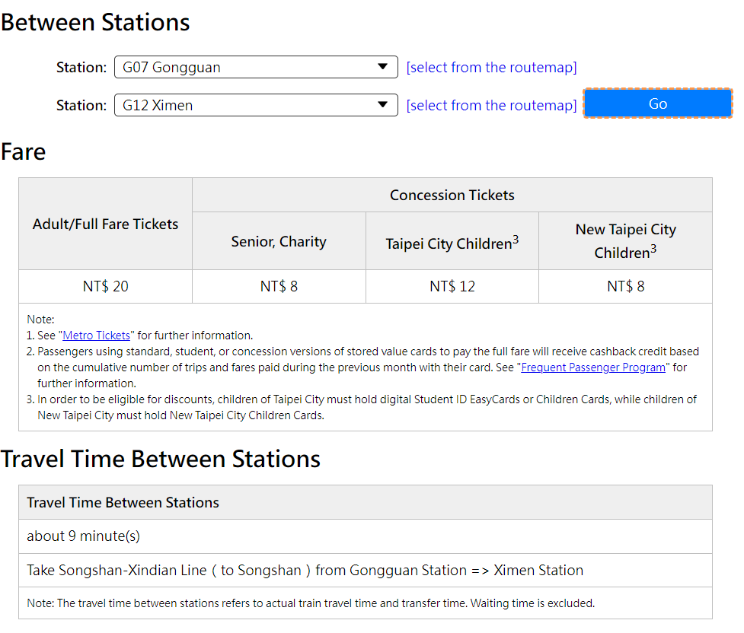

Traffic information
- From Taoyuan International Airport to Central Taipei
Most international flights land at Taoyuan International Airport (TPE). The journey from Taoyuan International Airport to central Taipei is about 40 kilometers.
Fom | Option | Route | Time (estimate) | Fare (estimate)
Taiwan Taoyuan International Airport (TPE) | Taxi | Taxis operating by shifts are located at the west side of Terminal 1's and 2's Arrivals Lobby | 1h | TWD 1,300
 | Bus → Taxi | Take bus (Kuo-kuang Line 1819 or CitiAir Bus 1961) directed to Taipei Main Station (臺北車站), and then take a taxi | 1h30 | TWD 350
 | Bus → MRT | Take bus (Kuo-kuang Line 1819 or CitiAir Bus 1961) directed to Taipei Main Station (臺北車站), and transfer to MRT Xindian Line (新店線), get off at Gongguan station (公館站) | 1h30 | TWD 220
 | Airport MRT  → MRT | Take Taoyuan Airport MRT to Taipei Main station (臺北車站), and then take MRT Songshan-Xindian Line (松山新店線) to Gongguan Station (公館站) | 1h15 | TWD 200
Resource: https://oia.ntu.edu.tw/en/internationalstudents/allyouneedtoknow/gettontu

Note:
- Take the MRT from Taoyuan Airport to Taipei, you can refer to this website, it will provide you with the time and price. You will take an MRT from a12 or a13 to a1 Taipei Main Station.
- https://www.tymetro.com.tw/tymetro-new/en/_pages/travel-guide/index.php?startStation=&endStation=&godate=2023-03-11&gotime=11%3A30

How to take Taipei Metro
1. How to Buy Tickets :
There are automatic ticket machines at each station. The machines only accept cash coins but you can always change a note into coins at the station. You may also purchase a ticket by the counter.

For more detailed information, please refer to this URL:
https://eng.taiwan.net.tw/m1.aspx?sNo=0029048

2. Ticket Prices and Types
It is recommended to use the automatic ticket vending machine to purchase tickets.
For more detailed information, please refer to this URL:
https://www.tymetro.com.tw/tymetro-new/en/_pages/travel-guide/ticket.html

3. NTU Campus Location
https://www.ntu.edu.tw/english/about/map.html

National Taiwan University Department of Geography Conference Room
https://www.geog.ntu.edu.tw/index.php/en/aboutus/contactus

