## Dear UM Connect Day visitor,

If you are coming by car, we have two free parkings at our Tapijn location (10 min walk to the School of Business and Economics, which is the starting location for the event).

*Please note that we do not have available parking at the School of Business and Economics.

**Parking spaces are limited so make sure to come in time.

## Parking 1 - Tapijnkazerne

Via the following Google Maps link, you can find the entrance of parking number 1:

<https://maps.app.goo.gl/VTRdsNbKprBQ2uxq8>

You will receive a parking ticket, which you have to scan at the Tapijn reception before leaving. Otherwise the barrier will not open upon exit.

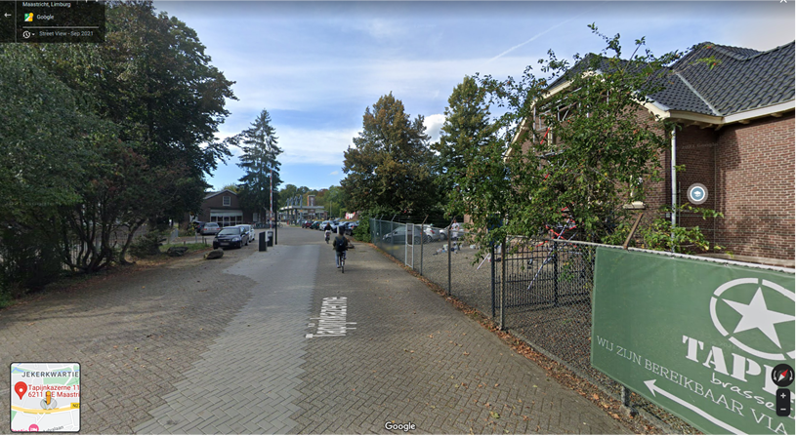

## Parking 2 - UMIO - Tapijnkazerne

Via the following Google Maps link, you can find the entrance of parking number 2:

<https://maps.app.goo.gl/G8HyP2UMqyVMkgVBA>

You will receive a parking ticket, which you have to scan at the Tapijn reception before leaving. Otherwise the barrier will not open upon exit.

