Venue, accommodation and transportation

Venue

Statistics Netherlands
Henri Faasdreef 312
2492 JP The Hague
Tel. + 31 70 3373800

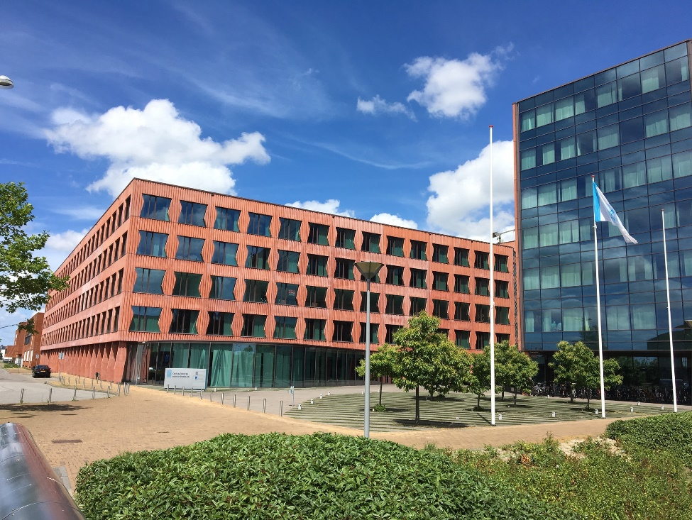

Accommodation

A selection of convenient located hotels, all situated in the centre of The Hague, are listed below.

- Hotel Mercure Den Haag
www.all.accor.com/hotel/317/index.nl.shtml
Address: Spui 180, 2511 BW The Hague (Den Haag)
Mercure Hotel Den Haag Central is located in the vibrant heart of The Hague and is easily accessible by car and public transport. The hotel is within walking distance of several ministries, the bustling shopping center and many theaters. The beach is just 15 minutes away.

- Holiday Inn EXPRESS THE HAGUE - Parliament
https://www.ihg.com/holidayinnexpress/hotels/nl/nl/the-hague/hagms/hoteldetail
Address: Lange Houtstraat 5, 2511 CV The Hague
The hotel is located in the centre of The Hague, close to the historical buildings of the Parliament, nice restaurants and bars.

- Hotel Ibis, Den Haag City Centre
www.ibis-den-haag-city.hotel-rn.com/index_nl.htm
Address: Jan Hendrikstraat 10, 2512 GL Den Haag
The hotel is located in the centre of The Hague, close to nice restaurants and bars.
- Park Centraal Den Haag
www.parkcentraal.com
Address: Molenstraat 53, 2513 BJ Den Haag
In the middle of the "Hofkwartier" nearby the Great Church, adjacent to the Palace Gardens and Palace Noordeinde, the unique four-star hotel Park Centraal Den Haag is situated.

- Novotel Den Haag City Centre
www.all.accor.com/hotel/1180/index.nl.shtml
Address: Hofweg 5-7, 2511 AA Den Haag
Novotel Den Haag City Centre is a 4-star hotel located in the historic Haagse Passage arcade right in the center of the city.
- Hotel Des Indes
www.hoteldesindes.nl
Address: Lange Voorhout 54-56, 2514 EG Den Haag
Traditional elegant hotel in the historical part of The Hague.
Leidschendam (sub urban area, Big Mall of the Netherlands)

- Fletcher Hotel
https://www.fletcherhoteldenhaag.nl
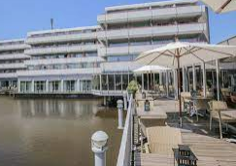 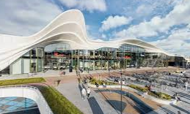
Fletcher Hotel-Restaurant Leidschendam-Den Haag is a pleasant stay near The Hague and Statistics Netherlands is easily accessible by public transport. The hotel has several comfortable facilities that you can enjoy (gym, bikes). The hotel is located in a sub urban area and next to the (new and biggest) Mall of The Netherlands for shopping and restaurants.

Scheveningen (The Hague beach) Taxi to CBS takes 15 – 20 minutes

- Grand Hotel Amrath Kurhaus
www.amrathkurhaus.com
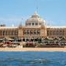
Historical elegant *****hotel at Scheveningen seaside, with the soothing sounds of the waves and the soft sea breeze washing over you. Wake up peacefully in one of our elegant rooms, filled with luxury perks for your visit to Scheveningen. As a hotel guest admission to our Spa & Beauty Centre is free of charge.

Hotel Boulevard Den Haag Scheveningen
www.boulevardhotel.nl
Small family hotel, The Boulevard Hotel, built on a dune top, is a comfortable family hotel next to the beach and the North Sea. Enjoy our magnificent view of the new boulevard of Scheveningen and the lovely beach feeling.

Travel information

There is a direct train connection between Schiphol International Airport and The Hague Central Station. It is the fastest and most convenient way to get to the city centre. The train station is situated directly below the airport (entrance via Schiphol Plaza). Please check: www.ns.nl/en/travellers/home to plan your journey up front.

Keep in mind that The Hague has other train stations, so be sure to travel to Den Haag CS (Central Station), as this station will be the closest to the Venue and the city centre. The journey time from Amsterdam Schiphol to Den Haag CS is about half an hour. A one-way ticket costs around 8 euro (second class) and 14 euro (first class). You can buy an anonymous OV-chip card or an one-way ticket at the ticket office or at the yellow ticket machines with the blue overhead sign reading ‘traintickets’. Only, when you booked the NH-hotel at the Prinses Margrietplantsoen you have to travel from Schiphol airport to Station Den Haag Laan van Nieuw Oost-Indië.

By tram or bus
The Hague has an efficient city wide system of light rail (called RandstadRail).
Centraal Station (CS) has easy access to trams on the south side (Rijnstraat), but the main lines (Randstadrail 3 and 4) stop on platforms crossing the main station hall at level 1.
Central Station is currently finishing up a major reconstruction work that may make some connections hard to find. Just ask at the information kiosk at the centre of the station.

From your Hotel to Statistics Netherlands (CBS):
CBS
Tram stop
When you are staying in The Hague/Den Haag: Take tram 3 or 4 in the direction of Zoetermeer. Get off at “Leidschenveen” station. If you leave the platform, you will see a footbridge ahead of you. This will lead you to the main entrance of the CBS building.

OV-chip card is valid for the entire public transport network in the Netherlands
We can advise you to buy an anonymous OV chip card ( for €7,50), as this is the Dutch public transport smartcard for all public transport in the Netherlands. The same card allows you to travel on the train, train, bus and metro. You can purchase these cards with a credit card at the yellow ticket machines, at Schiphol airport or you can buy them at the ticket office on the train station. Before you can travel you need to load credit onto the card.

Note: the OV-chip card/smartcard is rechargeable but not refundable. They are valid for five years so you can keep them for next visits to NL!

You must always check in and out with an OV-chip card. So hold your card against the card reader not only at the start of your journey, but also at the end of your journey, or when you transfer to another mode of transport.

For more information on the OV-chip card please see: https://www.ov-chipkaart.nl/

You can plan your journey using the Dutch Public Transport Planner: http://9292.nl/en

