Instructions on the abstract format

Abstracts are limited to one page of text and must include a graphical abstract. References should appear on the bottom of the first page. We will use your graphical abstracts as a teaser for the delegates on our website and in the program booklet. So, delegates will be intrigued to find out more about your important contribution to science and technology.
Ensure that image quality is suitable for online use but keep the abstract file size to 5MB at most. Please ensure that any text in your figures is large enough to read, when consider printing on an A4 page.
You MUST use our on-line abstract submission system to submit your abstract in pdf-format at www.hlse.nl. Abstracts will be peer reviewed according to originality of the work, specific results described, and potential impact. Please use Times Roman, Helvetica or Arial as your font 10 point or larger fonts should be used throughout, with the title presented in 14 point or larger.

Present the title and author list centered, while the paragraphs of the abstract should be left justified. Please ensure that the presenting author's name is underlined in the author list. Please also provide a contact e-mail. Use margins of at least 3.81 cm (1.5 inch) on both the left and right sides. An example of the abstract with some additional explanation on the expected content can be found on the next page. You can use this example directly as a template if you like.
Late submissions may be considered, but post-deadline papers will be accepted only if they report truly outstanding results. Thank you very much for participating in the HLSE Workshop.
In case you experience problems with the submission system or have other questions please approach the workshop host at r.luttge@tue.nl.

An Example Abstract for the 7th International Healthcare, Life-Science and Entrepreneurship Workshop

A. Einstein, C.A de Coulomb
Institute for Dreams, University College, Cambridge, MA 02139
einstein@university.edu

R. Fineman
HAL Laboratory of Quantum Studies, 137 Coupling Way, Pasadena, CA 91109

Significance: These first five lines need to explain in maximal 60 words what the central new finding of your work is. What is the novelty, which you present at the Healthcare, Life-Science and Entrepreneurship (HLSE) Workshop? Explain briefly what your main method is and provide the reader with a glimpse for audience your results are intended.

Methods: Elaborate here on the experimental or theoretical details of your work. Was it a numerical study or laboratory experiment? Make this section as concise and tailored to what you did and provide suitable reference material, where needed to be able to reproduce the research results. Cite appropriately when you took inspiration or build-on previous methods that are state-of-the-art in your field of research. If you need more detailed instructions on how to write a scientific abstract you may want to consult, for example, this website.

Results: After the Methods section explain how you arrive at your results, please provide here the reader in a structured way with all necessary information on what the experimental conditions are and how you collected and analyzed the data.
Describe what is it that you achieved in the most quantitative way you can imagine. In case your research is use-inspired please clearly state the field of application that take advantage of your results.
Next, we will be curious what your follow up work should entail to make the results even more important or complete. In case you demonstrated a proof-of-concept of a new technique, how do you envision, what your next steps will be?

Conclusion: This section is where give the reader a take-home message and how the results can make an impact. Why are your results innovative? State why your research makes a difference to the Healthcare and/or Life-Science domain. Is it fundamentally groundbreaking or does it lead to a solution for a technological challenge? Carefully check whether your data support your statement or indicate that a discourse on your findings is the main intention.
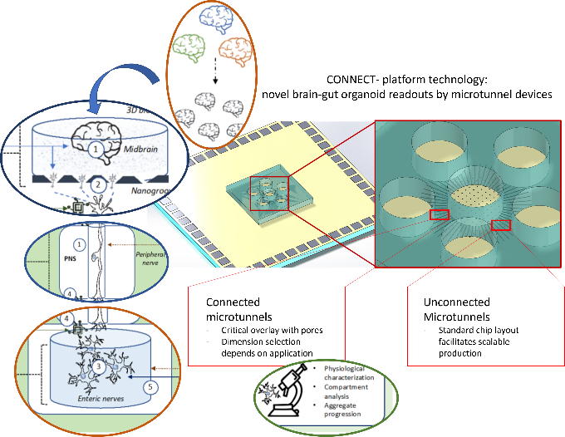

References should follow standard APS style guidelines. For more, see http://publish.aps.org/STYLE/ms.html
https://www.wiley.com/network/researchers/preparing-your-article/how-to-write-a-scientific-abstract accessed 01/04/2022

