A new approach to nature inclusive masonry quay walls: results from the “Green quays” project
Barbara Lubelli¹, Koen Mulder¹, Edwin Dijkhuis²

¹ Delft University of Technology, Faculty of Architecture, Dept. AE+T
² Floron

In the last years urban ecology gained increasing attention and greening the city has become one of the aims of many municipalities. In particular, walls, and among these quay walls, have the potential to be ecologically engineered to encourage a greater diversity and range of species [2]. Recently, research has therefore focused on the study of engineering solutions and materials to favour biological growth on (quay) walls.
The research presented here has been carried out in the framework of the Urban Innovation Actions project “Green Quays” [1], which aims at improving the bio-receptivity of brick masonry ,with the final aim to build nature inclusive quay walls in the Dutch city of Breda. Differently from other projects currently running in the Netherlands, in which plants are potted in mortar cavities and have roots in a compost layer located behind the masonry, the Green Quay project focuses on improving the bio-receptivity of the masonry building materials, in the attempt of stimulating spontaneous plant growth.
The project consists of 3 main phases: 1) laboratory research on bio-receptivity of masonry building materials; 2) in situ monitoring of small scale masonry walls; 3) large scale in-situ application. At the moment of writing, phase 1 is completed and phase 2 is running since about 1 year.

  - In the laboratory research, the effects of mortar components (binder, aggregates, additives) on relevant physical and mechanical properties of the mortar were assessed; then, the bio-receptivity of the mortars was evaluated, on specimens consisting of 2 bricks with a mortar joint (figure 1). The research highlighted that biological growth is possible in relatively fresh mortars, provided the conditions are favourable enough for this. [2] Some plant sprouts were observed to grow on the mortar, already few months after preparation. The effect of brick and mortar properties on bio-receptivity of masonry walls has been elucidated. The moisture transport properties of the brick-mortar combination and the composition of the mortar (mainly binder type and additions) were shown to be crucial for plant growth. Bricks and mortars with high porosity and mortars based on lime-trass and, in lower extent , on natural hydraulic lime, performed the best in terms of bio-receptivity. The addition of vermiculite to the mortar was shown to be very beneficial for plant growth.
  - When considering the mechanical strength, the brick-mortar combinations most favourable for plant growth were those with lower compressive and flexural bond strength. Therefore, for in situ applications in phase 2, a compromise was found. In addition to masonry with tooled bedding mortar joint, masonry with joints including bedding and pointing mortars were prepared for the in-situ small scale monitoring; the bedding mortar confers the necessary strength to the masonry, while the pointing mortar provides an optimal bio-receptivity. This way, possible damage to the pointing mortar does not compromise the structural stability of the masonry wall, as shown by mechanical tests carried out in laboratory [3].

For the in-situ monitoring of scale models, 10 masonry walls (2 m x 2 m x 0.43 m b x h x d) were built in April 2020 and placed in water in Breda (figure 2). 5 models are exposed to North and 5 to South, to assess the influence of solar radiation, rain and wind. Each small scale model is built with different bedding and pointing mortars: brick and mortar types were selected based on the results of phase 1. Each model is subdivided into three vertical parts; each of this parts has a different construction (figure 2). Seeds of ivy-leaved toadflax (Cymbalaria muralis) and the wallflower (Erysimum cheirie yellow) were added at the surface of the mortar and/or mixed in the pointing mortar during preparation.
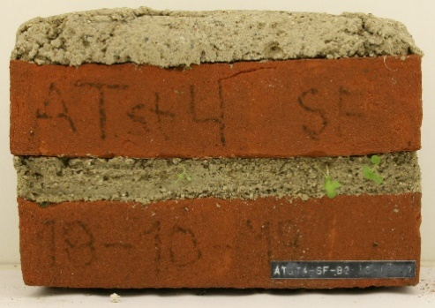
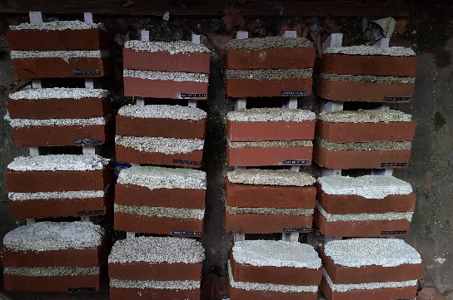

Figure 1. Brick/mortar specimens located in a sheltered location outside and sprayed at regular intervals (left); seedlings on specimen with trass-lime mortar and highly porous bricks
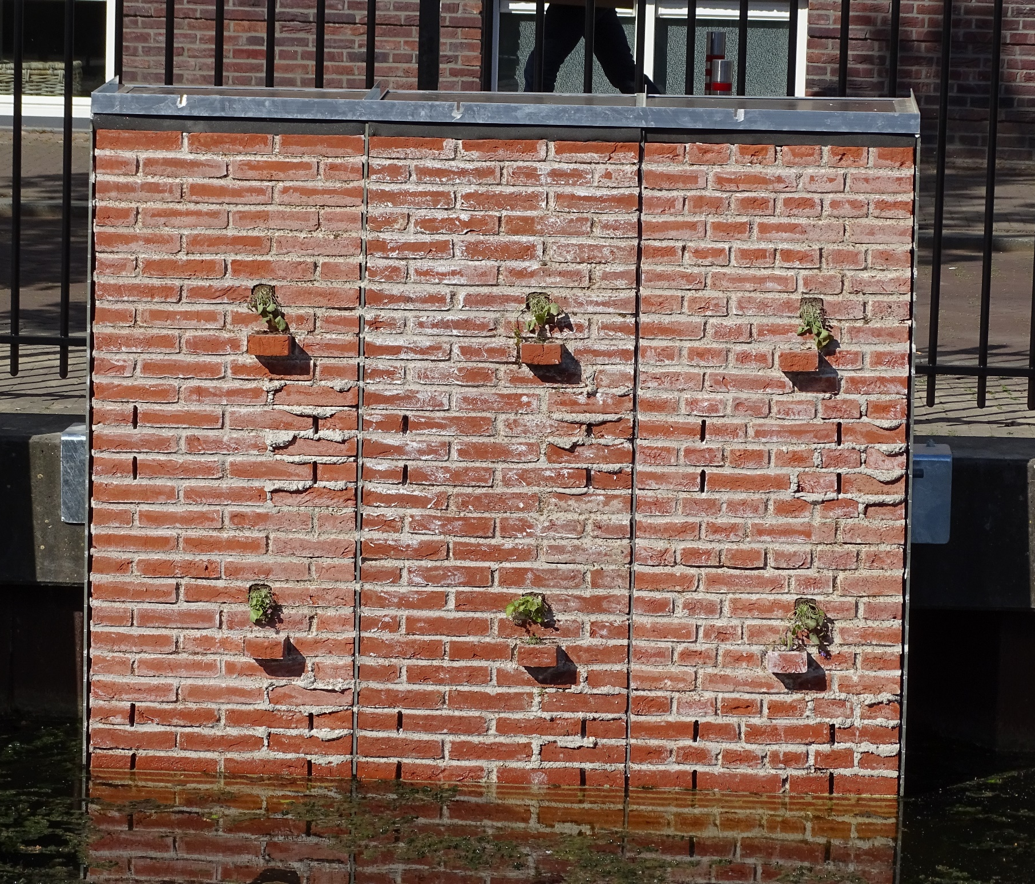
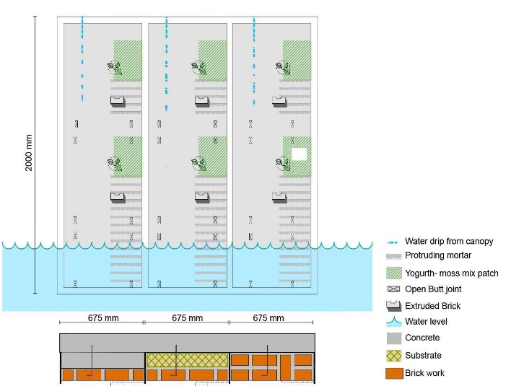

Figure 2. Schematic drawing of a small scale panel (left) and picture of one the panels, placed in water

The panels are being monitored for assessing the effect of the different variables (the construction, material properties and the environmental conditions) on the bio-receptivity of the masonry. Significant parameters to be monitored have been identified, related both to the masonry itself (biological growth, decay, moisture content, surface temperature) and to the environment (air temperature, RH and precipitations).
After about one year of monitoring, the following intermediate conclusions can be drawn:
- With respect to moisture content:
- The middle part of the masonry panels, with a compost behind the masonry wall, shows the highest moisture content. The left part of the masonry panels (half-brick thick masonry) shows a lower moisture content than the right part (one-brick thick masonry).
- The effect of the mortar composition on the moisture content in the wall is less relevant than that of the masonry structure (presence of compost layer and thickness of the masonry).
- Next to some moisture supplied by capillary rise (up to max 0,5 m from the water level), rain water from the top seems to play an important role in the water supply to the masonry.
- The assessment of the moisture content, carried out by the gravimetric method, has shown to be very much affected by the weather conditions. This makes it difficult to draw detailed conclusions about the effect of the different variables. Because of this reason, starting from May 2021, the moisture content in mortar will be additionally monitored by Time Domain Reflectometry (TDR) sensors.
- With respect to biological growth (seeds and potted plants): [4]
- The seeds germinated easier in the middle part of the panels (with compost layer behind the masonry). Only in the case of panel 5, with the most bio-receptive pointing, germination was observed also in the left and right parts the panel. Sidling have mostly grown in mortar joints nearby the water, in empty spaces and in the frog of protruding bricks. They were able to survive the dry periods.
- Based on the survey on February 2021, most of the plants potted in the left and right panels (without compost layer behind) died, most probably because of insufficient moisture content. The potted plants in the right panel, have surveyed for a longer period than those on the left panel.
Concluding, the preliminary results confirm the importance of the moisture content in the material for plant growth. This can be more easily achieved by the use of a compost layer behind the masonry. Germination of seeds is possible in relatively fresh (pointing) mortar, provided the material properties and the moisture content are both favourable.

References
[1] UIA project “Green Quays.” https://www.greenquays.nl/.
[2] B. Lubelli, J. Moerman, R. Esposito, and K. Mulder, “Influence of brick and mortar properties on bioreceptivity of masonry – Results from experimental research,” Constr. Build. Mater., vol. 266, p. 121036, 2021, doi: 10.1016/j.conbuildmat.2020.121036.
[3] G. Pardo Redondo, I. Bhatia, R. Esposito, B. Lubelli, and K. Mulder, “Green Masonry Walls: Study of the mechanical behaviour of solid brick veneer masonry favouring plant growth,” in preparation.
[4] E. Dijkhuis, K. Mulder, and B. Lubelli, “Groene kades langs de Nieuwe Mark,” Planten, no. 14, pp. 10–13, 2021.

Acknowledgments
The research was financed by the UIA project “Green Quays”. The authors wish to thank Jeroen Moerman and Ivneet Bathia for their contribution to the experimental research.

