​
Dear colleagues，

As it was announced before, we are very pleased to announce that the 8th International Bacterial Wilt Symposium (8th IBWS2026) will be held on 22-26 March 2026 in Wageningen, the Netherlands. The preparations regarding its organization are in full progress!
The registration is now open! Don't miss your chance to secure your spot and be part of interesting updates and discussions on bacterial wilt research.
This page is the official website of the 8th IBWS2026. You are welcome to keep updated via this website. Please forward this link to other people who might be interested.
If you have any questions or suggestions about the symposium, please contact the organizing committee by sending an e-mail to: ibws2026@gmail.com
We are looking forward to welcoming you to Wageningen, the city of life sciences in The Netherlands, for our 8th IBWS2026.

Best regards,
The 8th IBWS2026 organizing committee

Maria Bergsma-Vlami Florien Gorter
Chiel Pel
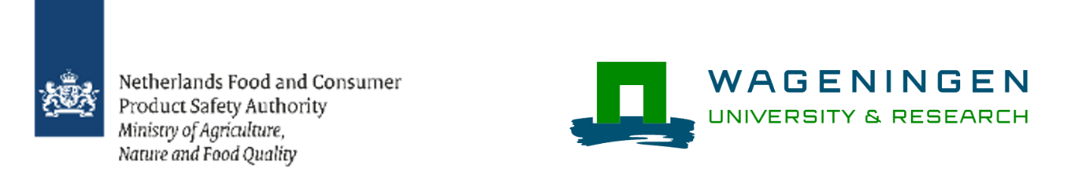​

Inge van Duivenbode Ellis Meekes
Sebastiaan van Kessel




