3rd Announcement
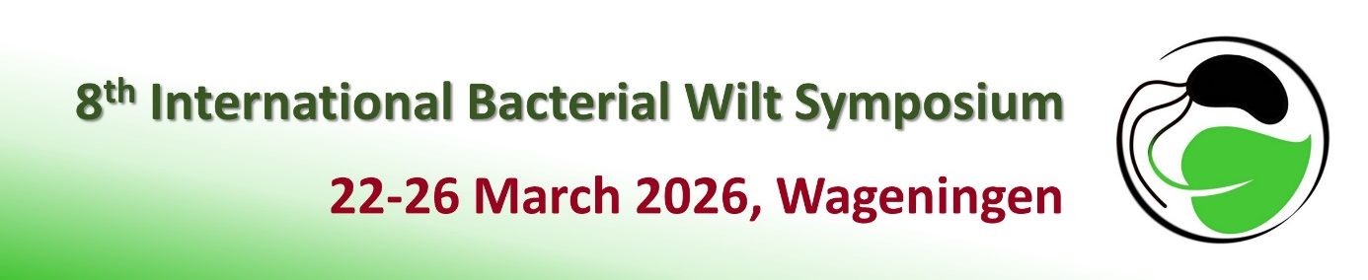
Dear Ralstonia community,
The registrations for the 8th International Bacterial Wilt Symposium (8th IBWS2026) are currently in full progress!
We would like to thank the colleagues that have already registered!

We would also like to inform you that the early bird registration has been extended until the 15th of November.
More information can be found in the official website of 8th IBWS2026: https://event.wur.nl/ibws2026

If you have any questions, please contact the organizing committee by sending an e-mail to: ibws2026@gmail.com

We are looking forward to welcoming you to Wageningen in March!

Best regards, on behalf of the 8th IBWS2026 organizing committee,
Maria Bergsma-Vlami,

