Instructions for Preparing a Paper for XV IAEG World Congress 2026
Author1 A.B. Lastname1¹, Author2 C. Lastname2², and Author3 D.E. Lastname3^{2,*}
¹ Department, Faculty, University, Address, Zipcode, City, (State), Country; email1@xxx.xx, ORCID 1111-1111-1111-1111
² Department, Institution, Address, Zipcode, City, Country; email2@xxx.xx, ORCID 2222-2222-2222-2222; email3@xxx.xx, ORCID
3333-3333-3333-3333
*corresponding author

Abstract
The abstract must not exceed 250 words and should not include figures, tables, or citations. The heading ‘Abstract’ should be typed in bold 11-point Times New Roman. The body of the abstract should be typed in normal 10-points Times New Roman. The abstract is a single paragraph without line breaks. Left and right indentations are set to 1.27 cm. Text is justified between the margins.

KEYWORDS: Provide 3 to 5 keywords, separated with a comma. End the list with a full stop. Use Times New Roman, 10 pt.

Introduction
Authors are invited to submit a paper through the Oxford Abstracts submission system before 1 February 2026. Accepted papers will be published open access by TU Delft Open Publishing with an individual DOI and will be submitted for indexing.
Please use this template to prepare your paper.
Paper must have a length between 3 and 8 pages (including references and optional tables, figures, contribution statement, and acknowledgements). On rare occasions, and subject to the approval of the Scientific Committee, overlength papers may be allowed, e.g., for papers describing a Case History that includes diagrams, photos, etc., or for a state-of-the-art paper additional pages. Please send requests for pre-approval of an overlength paper to info@iaeg2026.org. Papers should contain at least an abstract, keywords, introduction, main text, conclusion and up to 15 references.
The paper must be written in English. The title must be in 18-point Times New Roman with Title Case capitalization (i.e capitalize the first and last word and all nouns, pronouns, verbs, adjectives, and adverbs, do not capitalize minor words). The title may extend over more than one line. The paper must contain the names, affiliations, e-mail addresses, and ORCID numbers of the authors. If you do not have an ORCID number, you can register here: https://orcid.org/register. The author’s name or authors’ names should be in Times New Roman 10 pt. The first name of the author(s) is written in full, other given names are indicated with initials followed by the last name. The affiliation, e-mail address and ORCID number should be in 8 pt Times New Roman. The paper size is European A4 (21 x 29.7 cm). The left and right margins are 1.27 cm, the top margin (not including the header) is 2.5 cm, and the bottom margin is 1.9 cm. Do not edit any part of the headers or footers. Do not include blank space in the paper. Pages are numbered.

Section titles
Section titles are capitalized and bolt 11-point Times New Roman. Section titles are not numbered. No paragraph indents are used, and each paragraph is separated by 9-point spacing.

Subsection titles
Subsection titles are underlined 10-point Times New Roman. Subsection titles are not numbered.

Equations, Figures and Tables
Equations should be placed in a table numbered continuously, and centered on the page with the equation number outlined to the right according to the format shown below in Equation (1):
$$e^{iπ}+1=0$$ | (1)
where the unknown symbols are explained after the equation.
Figures, graphs and tables must be included using the same style as in Figure 1 and Table 1. Both figures and tables should be centered on the page. Use of at least 300 dpi resolution for pictures and line art is required. 1 px wide lines in figures should be avoided as they may become invisible in print. Permission must be obtained from the copyright holder when using third-party images. Proper credit must be given to the copyright holder. The Publisher is not responsible for any copyright infringement.
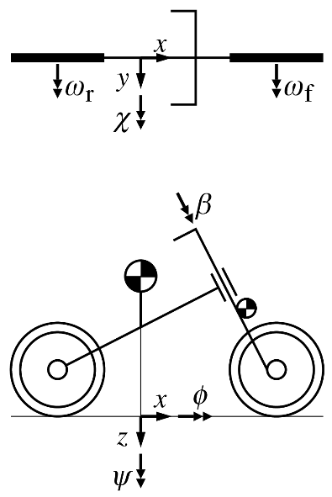
Figure 1. An example of a figure caption. Use 10 pt Times New Roman, placed below the figure. A reference to the image source should be included in the image caption if it is not original.

Table 1. Example of a table with a short caption. Caption should be placed above the table.
 | x | y | z
x' | α₁ | β₁ | γ₁
y' | α₂ | β₂ | γ₂
z' | α₃ | β₃ | γ₃

Bibliography
Bibliographical citations should be written in alphabetical order in the REFERENCES section at the end of the document and use the APA citation system and the APA 7 style. See the REFERENCES section below, where (Hanssen, 2001) and (Veen et al., 2025) exemplify the case of a book, (Vardon & Peuchen, 2020) is an article in a conference proceedings, and (Muntendam-Bos et al., 2022) is an article in a journal. References must be relevant and traceable. Always indicate the DOI, if it exists. When citing references limit self-citation and avoid over-reliance on works by the same authors.

Conclusion
Before submission, ensure that your manuscript is written clearly. All papers will be reviewed for quality and language and checked for plagiarism prior to acceptance. You may use AI tools solely to improve language and grammar or to create figures, provided you carefully verify the results and disclose the tools used and their purposes in the ACKNOWLEDGEMENTS.
Strict adherence to this template is essential for your paper’s acceptance and subsequent submission for indexing.
Please upload your finished manuscript as .odt or .docx through the Oxford Abstracts system. PDFs will not be accepted.
We very much look forward to receiving your paper and welcoming you in Delft! Best wishes and the warmest regards from the Organizing Committee of XV IAEG World Congress 2026.

Acknowledgements
Please acknowledge the relevant funding sources and co-workers that are not an author. Disclose any use of AI tools and their purposes.

Contribution Statement
Please indicate how each author contributed to this paper in terms of Conceptualization; Data Curation; Analysis; Investigation; Methodology; Visualization; Writing; Funding acquisition; Project administration; Supervision; Resources; Writing - Review & Editing; Supervision; Validation.

References
Hanssen, R. F. (2001). Radar interferometry: data interpretation and error analysis. Dordrecht: Springer Netherlands. https://doi.org/10.1007/0-306-47633-9
Muntendam-Bos, A. G., Hoedeman, G., Polychronopoulou, K., Draganov, D., Weemstra, C., van der Zee, W., Bakker, R. R., & Roest, H. (2022). An overview of induced seismicity in the Netherlands. Geologie en Mijnbouw/Netherlands Journal of Geosciences, 101(2), Article 202114. https://doi.org/10.1017/njg.2021.14
Rengers, N., Deketh, J. R., Hack, R., Huisman, M., Ngan-Tillard, D., Soeters, R., Verhoef, P., Verwaal, W., Slob, S., & van Westen, C. (2025). Hans Cloos lecture 2024: Five decades of education and research for engineering geology in the Netherlands. Bulletin of Engineering Geology and the Environment, 84(7), Article 362. https://doi.org/10.1007/s10064-025-04370-4
Vardon, P. J., & Peuchen, J. (2020). Using CPTs to derive thermal properties of soil. E3S Web Conf., 205, Article 04005. https://doi.org/10.1051/e3sconf/202020504005
Veen, J., Vis, G.-J., Jager, J., & Wong, T. (2025). Geology of the Netherlands: Second Edition. Amsterdam University Press. https://doi.org/10.5117/9789463728362

