28th Meeting of the Wiesbaden Group on Business Registers
The Hague, Netherlands, 2 – 6 October 2023
Name of the author(s): KUREMATSU Ryosuke, TANABE Tatsuya
Organization: Statistical Business Register Management Division, Statistics Bureau in Japan
Session 6: New Data sources: Opportunity and challenges
Efforts for Further Development and Enhancement of the Statistical Business Register in Japan
- Improvement of Update Frequency -

1. Introduction
The Statistical Business Register in Japan (JSBR) is maintained by using the data obtained from statistical surveys such as the Economic Census as the primary source of data, and by additionally utilizing administrative data.
Concerning the JSBR's coverage, there is a problem: while the main source is the data obtained through statistical surveys, even small-scale business establishments have not been accurately captured. In the 2019 Economic Census, approximately 1,600,000 corporations were newly added to the survey list by collating the corporate number, which is an administrative record, with the JSBR; then, the expansion of coverage was realized by conducting the census.
However, in the 2019 Economic Census, for business establishments in operation, in order to reduce the burden on enumerators and local governments due to the increase in the number of establishments covered, enumerators only checked their activity status from the outside appearance. For this reason, the 2019 Economic Census did not obtain the basic items such as sales and the number of workers of business establishments in operation. The new challenge is to increase the frequency of updating these basic items of business establishments in operation. Therefore, from 2023, the scope of the Establishment / Enterprise Inquiry and the Economic Census for Business Frame were revised, which enables us to update basic items of the top 90% of sales of enterprises every year. As a result, the data of major business establishments and enterprises is reflected in the JSBR as the latest data every year. As a population of economic statistics surveys targeted at business establishments and enterprises, this is expected to contribute to the improvement of the accuracy of various economic statistics and the reduction of the burden on the respondents such as double correction.
This paper introduces the outline of the JSBR and the efforts to improve the JSBR renewal frequency from 2023.

2. Brief Introduction to the JSBR
The JSBR is developed based on Article 27, Paragraph 1 of the Statistics Act. Based on the results of the Economic Census and other statistical surveys, administrative record data (labor insurance information, commercial and corporate registration, etc.) is integrated and updated regularly. This database captures data from all the business establishments and corporations and maintains the latest data. In addition, the population data on business establishments and enterprises recorded in the JSBR is used for sampling conducted by administrative organs and is critical to producing accurate economic statistics (Fig 1).
The items included in the JSBR are based on the survey items of the Economic Census, and include items in high demand, such as industrial classifications, the number of workers, and sales amounts (income). The main functions of the JSBR are as follows:
a. Provision of population data for various statistical surveys
b. Leveling the burden on survey respondents (duplicate correction)

The outline of the Economic Census, the Annual Business Survey, and the Administrative Data, which are the main data sources of the JSBR, are as follows:

2.1 Economic Census
The Economic Census is a fundamental statistical survey aimed at clarifying the state of economic activities of business establishments and enterprises, clarifying the comprehensive industrial structure in Japan, and preparing population data for conducting various statistical surveys of business establishments and enterprises.
The economic census consists of two parts: The Economic Census for Business Frame (EC-BF), which reveals the basic structure of business establishments and enterprises, and the Economic Census for Business Activity (EC-BA), which reveals the state of economic activities of business establishments and enterprises.
The purpose of the EC-BF is to survey the state of activities of business establishments and enterprises, to develop population data, and to clarify the basic structure of industries and employees of business establishments and enterprises nationwide and by region. The survey is conducted once every five years in the interim year.
The purpose of the EC-BA is to comprehensively grasp accounting items such as sales amount and expenses of all industries, to clarify economic activities of business establishments and enterprises nationwide and by region, and to obtain population data for statistical surveys of business establishments and enterprises. The survey is conducted once every five years (base year).

2.2 Annual Business Survey
The Annual Business Survey (ABS) is conducted every year (except the years in which the EC-BA is conducted) in order to identify the structure of all industries such as their added value and to contribute to improving the accuracy of national accounts.

2.3 Administrative Data
Labor insurance data, commercial and corporate registration, and EDINET are used as data sources for administrative data. In addition, in order to capture basic items and adjust the time point, which is lacking in administrative data, the Establishment / Enterprise Inquiry (EEI) is conducted before adding them to the JSBR. This is not a statistical survey, but a survey for the JSBR improvement based on Article 27 of the Statistics Act.

Fig 1: The Image of the JSBR

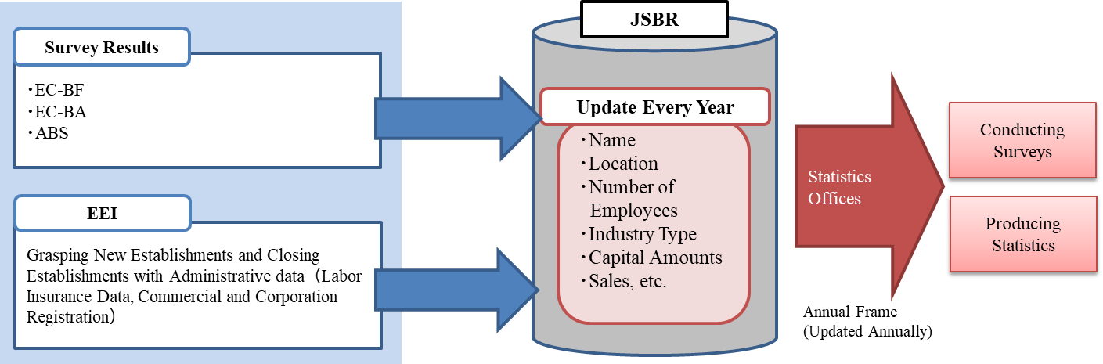

3. Building the Corporate Number and the Coverage Expansion of the JSBR
Although the JSBR was developed based on the above data, there was a problem concerning the coverage: "We have not been able to capture the entire Japanese business establishments, small business establishments in particular."
Since the administrative data called "Corporation Number" was established in 2013, in the implementation of the 2019 EC-BF, corporations listed on the Corporation Number Disclosure Website were compared with the JSBR by name and location. For corporations in the Corporation Number Disclosure Website that did not match corporations in the JSBR, the status of notification of the Corporation Number (the status of delivery by mail) was checked. Approximately 1,600,000 corporations that had not been listed in the JSBR until then were newly added to the survey list, and the 2019 EC-BF was conducted.
As a result of the 2019 EC-BF, we were able to confirm the activities of about 1,000,000 corporations out of about 1,600,000 corporations. On the other hand, the remaining 600,000 corporations were not identified even by enumerators. Storing the results in the JSBR made the coverage of the JSBR greatly expanded.
Additionally, it was revealed that many of the approximately 1,000,000 corporations whose activity status could be confirmed had private residences or apartment rooms that were difficult to capture the activity status by enumerators and that many corporations were very small in terms of capital.
Furthermore, about 600,000 corporations whose existence could not be confirmed by the enumerators are considered to be those whose registration has not been closed despite the lack of actual business activities.

4. Improvement of Update Frequency of the JSBR from 2023
As mentioned earlier, the 2019 EC-BF achieved a great expansion of the JSBR coverage. However, in the 2019 EC-BF, from the viewpoint of reducing the burden on local governments and enumerators, the distribution of questionnaires to identify basic items (industry, size of employees, sales, etc.) was limited to newly identified business establishments. For existing business establishments, the enumerators only identified their activities from the outside appearance. Therefore, the basic items were not identified, and the data on the basic items of existing business establishments and enterprises was not updated in the JSBR. Therefore, from the viewpoint of improving the utility of the JSBR in the interim year, the frequency of updating the basic items of existing business establishments and enterprises has become a new issue.
Until then, the basic data of business establishments and enterprises with sales of the top 80% or more was updated every year in the ABS. Moreover, expanding the scope of the EEI from 2023 and the EC-BF in 2024 enables us to update the basic data of business establishments and enterprises with sales of the top 90% every year (Fig 2). As a result, it is expected that the frequency of the JSBR updates will increase, and by providing the latest data as the population of statistical surveys for business establishments and enterprises, it will contribute to improving the accuracy of various economic statistics and reducing the burden of reporting by multiple corrections, etc.
The outline of the new EEI and the new EC-BF from 2023 as a new data source is as follows:

4.1 New Data Source: The Establishment/Enterprise Inquiry from 2023
In the past, the EEI was carried out only for limited targets: new establishments or closing establishments captured using administrative data. From 2023, the EEI will expand the target to the enterprises in operation with multiple business establishments and survey basic items such as sales and number of workers, and the results are reflected in the JSBR.
The number of existing enterprises with multiple offices (survey target) is about 260,000 enterprises (the number of affiliated offices is about 1,450,000), and the survey is conducted online and by mail. The fundamental statistical surveys, the Economic Census, and the ABS are obliged to answer questions, while the EEI is not obliged to answer questions.
In addition to the results of the ABS, the implementation of the new EEI from 2023 makes it possible to reflect basic items in the JSBR every year in a timely manner in the range covering the top 90% of sales of enterprises, thereby increasing the update frequency of the JSBR.

4.2 New Data Source: The 2024 Economic Census for Business Frame
The EC-BF is conducted once in the interim year. In the 2024 EC-BF, basic items are also going to be surveyed for business establishments in operation. On the other hand, as a survey method, we decided not to utilize enumerators and to carry out the census online and by mail using private business operators. As for the scope of the census, taking cost-effectiveness into account, unincorporated enterprises without employees, which account for only 0.4% of total sales, are excluded from the census target. In terms of sales, the EC-BF covers approximately 99.6% of all enterprises. In addition to the ABS and the EEI, the EC-BF covers a wide range of renewals in a given year. This makes it possible to provide the 2025 EC-BA with the latest population data.
In 2024, the EC-BF is going to be conducted simultaneously and in an integrated manner with the ABS. For example, the survey-related documents are going to be distributed using a common envelope for the respondents for both surveys, and answers are not going to be required for questions with overlapping items by pre-printing "*" in the response column. This is intended to alleviate the burden on the respondents (the data answered in the ABS is shared with the EC-BF).

Fig 2: The Relationship between the Area of the Surveys and Updated Areas of the JSBR
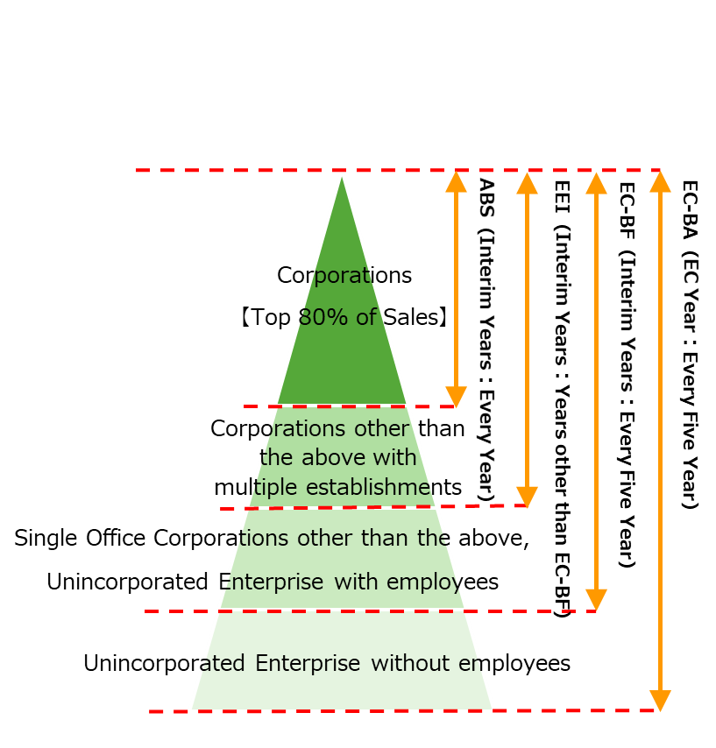
Top 99.6 % of sales
Top 90 % of sales
Top 80 % of sales

5. Schedule
We conducted the ABS and the EEI in 2023, and we are going to conduct the EC-BF and the ABS in 2024. We are going to continue to update the JSBR in the cycle of the survey in Fig 3 and provide the most up-to-date population data.

Fig 3: The Cycle of Surveys Used to Update the JSBR
Base Year | Interim Years |  |  |  | Base Year
2021  （Result） | 2022  （Result） | 2023  （Result） | 2024  （Plan） | 2025  （Plan） | 2026  （Plan）
・EC-BA | ・ABS  ・EEI | ・ABS  ・EEI | ・ABS  ・EC-BF | ・ABS  ・EEI | ・EC-BA

An upper limit for the number of statistical surveys that can be conducted per year (the number of surveys to be conducted) is set for each business establishment and enterprise, and business establishments and enterprises that exceed the upper limit are excluded from the sample surveys to avoid duplication.
A statistical survey to produce statistics that are important in planning national policies, such as Population Census. Fundamental statistical surveys are obliged to be answered by the Statistics Act.
Under the Financial Instruments and Exchange Act, this is an electronic disclosure system for disclosure documents such as securities reports, which are corporate information disclosed by listed companies issuing shares.
The National Tax Agency established the Law Concerning the Use of Numbers to Identify a Specific Individual in Administrative Procedures (hereinafter referred to as the "Number Law") in May 2013. (Designation of a Corporation Number) The National Tax Agency publishes the Corporation Number on the Corporation Number publication site together with the trade name or name and the location of the head office or principal office of the subject corporation. Each corporation is assigned a 13-digit corporate number, which is freely available to anyone in principle. The purpose of the Corporation Number is to create new value and to serve as a social foundation for realizing a fair and equitable society by improving the efficiency of administration and increasing the convenience of citizens. The use of the Corporation Number in public statistics is the most appropriate for this purpose. Based on the "Basic Policy for Statistical Reform" (December 21, 2016) compiled by the Council on Economic and Fiscal Policy, the use of the Corporation Number is to be promoted in statistical surveys targeting business establishments and enterprises.

