Frontiers of Nanomechanical Systems (FNS) workshop
June 6-9, 2023, Delft, The Netherlands

ABSTRACT TITLE

First Author¹, Second Author^{*1,2}, Third Author²
¹Department name, Institution 1
²Department name, Institution 2
*contact: correspondingauthor@email.com

This is the template for abstracts to be presented either as an invited/contributed talk or a poster presentation at the forthcoming FNS workshop in Delft, The Netherlands, from June 6-9, 2023.
In the list of authors, the name of the presenting author must be underlined. The font to be used shall be Helvetica or Arial (10 pt). Start your abstract with some background and motivation, and then describe your approach and summarize your key results. We recommend adding an eye-catching figure. Make sure that the total length of the abstract is no more than 1 page.
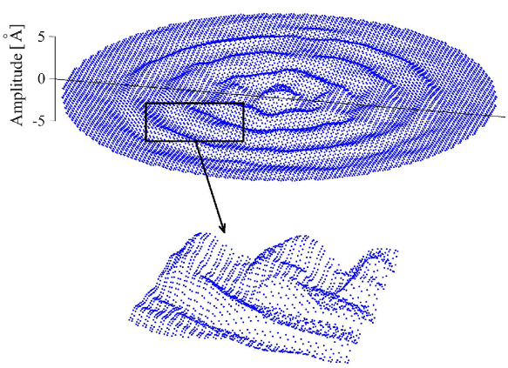
Figure 1: Sample figure.
Any references should appear together at the end of the abstract, listed chronologically. Cite in the text using commands [1, 2] or [1-3]

References
[1] I. E. Rosłon, A. Japaridze, P. G. Steeneken, C. Dekker, and F. Alijani. Probing nanomotion of single bacteria with graphene drums.
Nature Nanotechnology, 17(6):637–642, Jun 2022.
[2] A. Bachtold, J. Moser, and M. I. Dykman. Mesoscopic physics of nanomechanical systems, 2022.
[3] R. J. Dolleman, P. Belardinelli, S. Houri, H. S. J. van der Zant, F. Alijani, and P. G. Steeneken. High-frequency stochastic switching of
graphene resonators near room temperature. Nano Letters, 19(2):1282–1288, 2019.

