Visiting Statistics Netherlands

Venue address The Hague
Statistics Netherlands
Henri Faasdreef 312
2492 JP The Hague
Tel. + 31 70 3373800

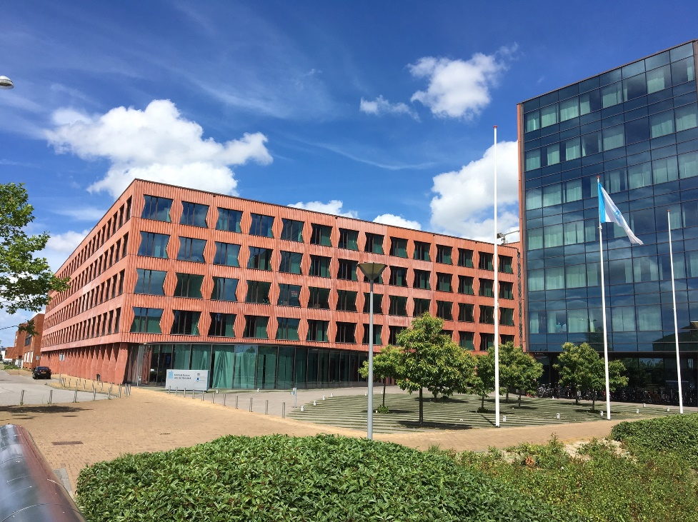

Travel information
Traveling from Schiphol Airport to The Hague
There is a direct train connection between Schiphol International Airport and The Hague Central Station (Den Haag centraal). It is the fastest and most convenient way to get to the city. The train station is situated directly below the airport (entrance via Schiphol Plaza).

The journey time from Amsterdam Schiphol to Den Haag Centraal is about half an hour to 45 minutes and a direct train to Den Haag Centraal departes roughly every 15 minutes. A one-way ticket costs around 10 euro (second class) and 17 euro (first class).

Traveling from Eindhoven Airport to The Hague
After arrival at Eindhoven, you first have to take a bus to the train station Eindhoven Centraal.
When traveling by bus usually Google Maps is the most convenient way to find which bus to take.

From Eindhoven Central Station once every half an hour a direct train travels to The Hague Central Station.
Including the bus traveling from Eindhoven Airport to The Hague Central Station takes approximately 2 hours of travelling time. A one way ticket costs a little more than €15,- if you pay up front with an e-ticket. At the NS ticketmachine you will pay approximately €25,-.

You can buy an anonymous OV-chip card (read more under By tram or bus) or a one-way ticket at the ticket office or at the yellow ticket machines with the blue overhead sign reading Train tickets.

Keep in mind that The Hague has other train stations, so be sure to travel to Den Haag Centraal (The Hague Central Station), as this station will be the closest to the city centre.
Please check: https://www.ns.nl/en to plan your journey by train up front and order e-tickets.

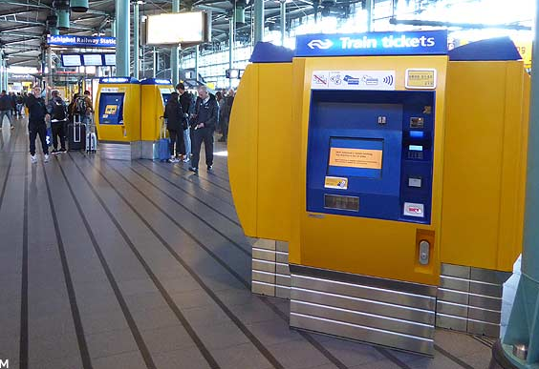

By tram or bus
The Hague has an efficient city wide system of light rail (called RandstadRail). Centraal Station (CS) has easy access to trams on the south side (Rijnstraat), but the main lines (Randstadrail 3 and 4) stop on platforms crossing the main station hall at level 1. If you are not sure, ask at the information kiosk at the centre of the station.

For traveling by all public transport in the Netherlands (train, bus, tram and metro) you can use an OV-Chipcard. You can buy an anonymous card for about €8,50 at the larger stations. After this you have can choose what amount of money you want to put on the card and start your travel. The OV-chip card is rechargeable but not refundable. They are valid for five years so you can keep them for next visits to The Netherlands.

However, if this is a possibility, the most convenient way to travel is with your own contactless debit or credit card issued by Maestro, V PAY, Mastercard or Visa. This is called OVPay and is more convenient since you do not need to use another card and also saves you money from the amount that maybe stored on your anonymous card after you have used it. You can also use OVPay with your smartphone set up with contactless payment with a card from above-mentioned debit and credit cards. Also using Apple Pay and Google Wallet gives the possibility to use OVPay.

For more information on travelling using a contactless debit or credit card
https://www.ovpay.nl/en/how-it-works
And for more information on using an anonymous OV-Chipcard visit the website below.
https://www.ov-chipkaart.nl/en

Use your OV-chipcard, OVpay on your contactless debit or credit card, or your phone to check in and out at the dedicated card readers.
In the trams and busses these card readers are situated in the tram and busses themselves. When traveling by metro of train the card readers are situated near the entrances and usually at the gateways before the platform. And when in Rome…. Take a peek at how other travellers use the card readers.

From your hotel to Statistics Netherlands (CBS):
CBS
When you are staying in The Hague: Take Randstadrail 3 in the direction of Centrum West (Zoetermeer) or Randstadrail 4 in the direction of Lansingerland (Zoetermeer). Get off at station Leidschenveen. If you leave the platform, there is a footbridge ahead of you. This will lead you to the main entrance of the CBS building.

Plan your journey with HTM, the transport company for most trams and busses in the region of The Hague.
https://www.htm.nl/en/

Accommodations in The Hague

The Hague city center
A selection of hotels, all situated in the centre of The Hague, is listed below. Being in the centre, all of them are close to nice restaurants and bars, historical sites and the big shopping areas.

- Hotel Mercure Den Haag
Address: Spui 180, 2511 BW The Hague (Den Haag)
https://all.accor.com/hotel/1317/index.nl.shtml

- Holiday Inn EXPRESS The Hague - Parliament
Address: Lange Houtstraat 5, 2511 CV The Hague
https://www.ihg.com/holidayinnexpress/hotels/gb/en/the-hague/hagms/hoteldetail

- Ibis Den Haag City Centre
Address: Jan Hendrikstraat 10, 2512 GL Den Haag
https://all.accor.com/hotel/3701/index.en.shtml

- Park Centraal Den Haag
Address: Molenstraat 53, 2513 BJ Den Haag
https://www.parkcentraal.com/den-haag/

- Novotel Den Haag City Centre
Address: Hofweg 5-7, 2511 AA Den Haag
https://all.accor.com/hotel/1180/index.en.shtml

Leidschendam
This is the area close to the CBS venue. Traveling 20 minutes from this hotel with one tram (tram 19, in the direction of Delft) takes you to the CBS building in The Hague. In this area you can visit the Westfield Mall of the Netherlands, this shopping centre is completely covered and includes about 200 shops as well as restaurants a fresh market and cinema (films are screened in original language with Dutch subtitles).

- Fletcher Hotel
Address: Weigelia 22, 2262 AB Leidschendam
https://www.fletcherhoteldenhaag.nl/en/

Scheveningen - The Hague beach
Stay here if you want to visit The Hague beach. Traveling from this location takes you in approximately 35 to 45 minutes to the CBS location taking different busses. Use Google Maps to navigate and choose the quickest route as there are many options for public transport.

- Grand Hotel Amrâth Kurhaus
Address: Gevers Deynootplein 30, 2586 CK Den Haag
https://www.amrathkurhaus.com/en/

- Boulevard Hotel Scheveningen
Address: Seinpostduin 1, 2586 EA Den Haag
https://www.boulevardhotel.nl/en/

